A DISSERTATION ON

**“Design and Testing of lightweight sandwich composite T-Joint using FEA and Experimental Techniques.”**

By

**Abhishek Tekwade (B150300938)**

**Atharva Bhange (B150300811)**

**Maheshwari Khillari (B150300868)**

**Ruturaj Hodage (B150300844)**

Guided By

**Prof. Sachin .S.Yadav**



**Department of Mechanical Engineering**

**Genba Sopanrao Moze College of Engineering, Balewadi [2021-2022]**

**Genba Sopanrao Moze College Of Engineering,**



**C E R T I F I C A T E**

This is to certify that

**Abhishek Tekwade, Atharva Bhange, Maheshwari Khillari, Ruturaj Hodage**.

has successfully completed the Dissertation entitled **“Design and Testing of lightweight sandwich composite T-Joint using FEA and Experimental Techniques.”** under my supervision, in the partial fulfillment of Bachelor of Engineering - Mechanical Engineering of Savitribai Phule Pune University.

**Date:**

**Place:**

**Guide Name External Examiner**

**Head of Department Principal**

**(Prof.S.R.Sandanshiv) Seal (Dr.Ratnaraj Kuma Jambi)**

**ACKNOWLEDGEMENT**

It gives us great pleasure to present a dissertation on “**Design and Testing of lightweight sandwich composite T-Joint using FEA and Experimental Techniques.**” A number of people helped us during the completion of this project. Thus, it becomes our duty to express our gratitude towards them.

I am deeply indebted to my Dissertation **Prof. Sachin Yadav** and the Head of Mechanical engineering department **Prof. S.R.Sandanshiv** for their valuable suggestions, scholarly guidance, constructive criticism and constant encouragement at every step of the Project.

We will fail in our duty if we don’t acknowledge a sense of gratitude to The Principal **Dr.R.K.Jambi** , President Hon **Shri. Rambhau Moze** and special thanks for entire staff of the Mechanical Engineering Department for their cooperation and support.

Table of Contents

Abstract

**Chapter 1: Introduction**

* 1. Problem Statement
  2. Objective
     1. FEM Work
     2. Experimental Work
     3. Comparison and Verification by FEM
  3. Composite Structure of T Joint
     1. Function of T Joint
     2. Organization of Dissertation

**Chapter 2: Literature Review**

2.1 Literature Review

2.1.1 Outcomes of Literature Review

**Chapter 3: Solid Modelling of Composite T Joint**

3.1 Solid Modelling Method

3.1.1 CSG (Constructive Solid Geometry)

3.1.2 B- REP (Boundary Representation)

3.1.3 FBM (Feature Based Modelling)

3.2 Building Clean Geometry

3.2.1 Sketcher

3.2.2 Part Design

3.2.3 Assembly Design

**Chapter 4: Finite Element Analysis**

4.1 FEM Approach

4.2 Description of Method

4.3 Physical Problem, Mathematical Models & Finite Element Solutions

4.4 Steps followed in FEA

4.4.1 Preprocessing

4.4.2 Solution

4.4.3 Postprocessing

**Chapter 5: Material Selection**

5.1 Resin

5.1.1 Adhesive Properties

5.1.2 Mechanical Properties

5.3 Fibre Glass

5.4 Foam Cores

5.4.1 PVC Foams

5.4.2 Polystyrene Foams

5.4.3 PMI Polyetherimide Foams

5.4.4 Other Thermoplastics

**Chapter 6: Design of Composite T Joint**

6.1 T Joint Design Concept

6.2 3D Modeling

**Chapter 7: Manufacturing of T Joint**

7.1 Hull and Bulkhead

7.2 Design of T Joint

7.3 Manufacturing of T Joint

7.4 Core Pieces

7.5 Filler Triangle

7.6 Overlaminate

7.7 Fixture Manufacturing

7.8 Joining Method

7.8.1 Hand/ Wet Lay Up Method

**Chapter 8: Experimental Stress Analysis**

**Chapter 9: Analysis of T Joint**

**Chapter 10: Result and Discussion**

**Chapter 11: Conclusion**

**Chapter 12: Future Scope**

**REFERANCE:**

**List of Figures**

|  |  |  |
| --- | --- | --- |
| Fig. No. | Title | Page No. |
| 1.1 | 3D model (60) | 9 |
| 1.2 | 3D model (45) | 10 |
| 1.3 | Basic dig. of T-joint | 13 |
| 3.1 | 3D CATIA view of T-joint | 18 |
| 4.1 | Plane 82 element | 23 |
| 4.2 | Free or mapped element | 23 |
| 5.1 | Model of perfectly bonded lamina | 26 |
| 5.2 | Comparitive Tensile strength & stiffness of resin | 28 |
| 5.3 | A general plain weave fabric lamina | 29 |
| 6.1 | 2D drawing of T-joint | 31 |
| 6.2 | 3D model of CATIA | 34 |
| 7.1 | 2D view of component of composite T-joint | 36 |
| 7.2 | Typical mould arrange of fibre Pringle | 38 |
| 7.3 | Wet/ Hand Lay Up | 39 |
| 9.1 | Meshing of comp.T-joint | 47 |
| 9.2 | Constraints & force applications of T-joint | 48 |
| 9.3 | Analysis & deflection of T-joint at 20KN | 49 |
| 9.4 | Analysis & deflection of T-joint at 50KN | 50 |

**List of Tables**

|  |  |  |
| --- | --- | --- |
| Table No. | Title | Page No. |
| 1.1 | Materials & its specifications of T-joint | 12 |
| 2.1 | Brief review of literature | 15 |
| 4.1 | Material properties of each part | 22 |
| 6.1 | Quantity & material requirement | 32 |
| 7.1 | Dimensions & quantity of PVC | 35 |
| 8.1 | Specifications of UTM | 42 |
| 8.2 | Failure load of static analysis | 44 |
| 9.1 | Material property of each part | 46 |
| 9.2 | Load application in Analysis | 49 |
| 10.1 | Comparision & result | 51 |

**Abstract**

A large amount of research is going on with the objective to strengthen the technological basis for the large scale application of fiber reinforced composite materials for naval vessels and structures. Fiber reinforced composites are widely used in naval ships and aerospace, ground transport, civil infrastructure because of their high strength and stiffness, low mass, excellent durability and ability to be formed into complex shape. Naval superstructure need to be designed with confidence on the basis of modeling and failure prediction. T-joint consists of a horizontal base panel, a vertical leg panel and fillet and over laminates. The purpose of the fillet is to provide the continuity of the load transfer between the base panel and the leg. The over laminate is used to enhance the capacity of the T-joint. Reduction of weight and increasing strength of the T-joint is one of the objectives. Performance testing of composite sandwich T-joints subjected to both static and dynamic loading commonly used in large panels for naval applications becomes very important. Adhesively bonded T-joints have been extensively used in assembling sandwich structures made from glass fiber reinforced plastic skins and a balsa wood core in naval vessels. Prototype is build for experimental validation and is validated through FEA and experimental results. The advantage of adhesive bonded joints over bolted or riveted joints is that the use of fastener holes in mechanical joints inherently results in micro and local damages to the composite laminate during their fabrication. The aim of this work is to investigate the behavior of composite T joints used in marine applications due to variation of different parameters. Index Terms—composite Material, Fiber Reinforced Plastic (FRP) , superstructures, laminates .

**CHAPTER 1.**

**INTRODUCTION**

Reducing the structural weight and improving the fuel eﬃciency represents the keys of cost operation in most commercial industrial applications. Thus, the use of composite sandwich structures are extensively increasing for a range of applications, particularly in aircraft, automobiles, satellites, bridge constructions, wind energy systems, and ship hulls. One of the most common advanced composite materials is Fibre Reinforced Plastics (FRP). In marine applications, FRP has been used to build many types of ships, including pleasure craft, ferries and naval mine-hunters or Mine-Counter-Measure-Vessels. The use of composite materials for military applications is desirable, especially because of some of the material characteristics which are absent in metal-hulled ships, such as lighter weight, corrosion resistance and design flexibility due to its anisotropic nature. Moreover, the non metal-hulled ships, such as composite materials have the capability to be a radar proof, which means that it allows the ships to go through the enemy zone undetected. It makes the composite materials even more attractive for military applications. Fibres, in general, possess higher tensile strengths compared to the tensile strengths of the same material in the bulk form which is due to one or more of the following reasons.

(a) Absence of defects of a critical size

(b) Non-equilibrium structures obtained during preparation of fibres.

(c) Orientation of molecules along the fibre direction in the case of molecularly anisotropic materials like polymers.

(d) Favourable residual stresses introduced during the fibre manufacturing process.

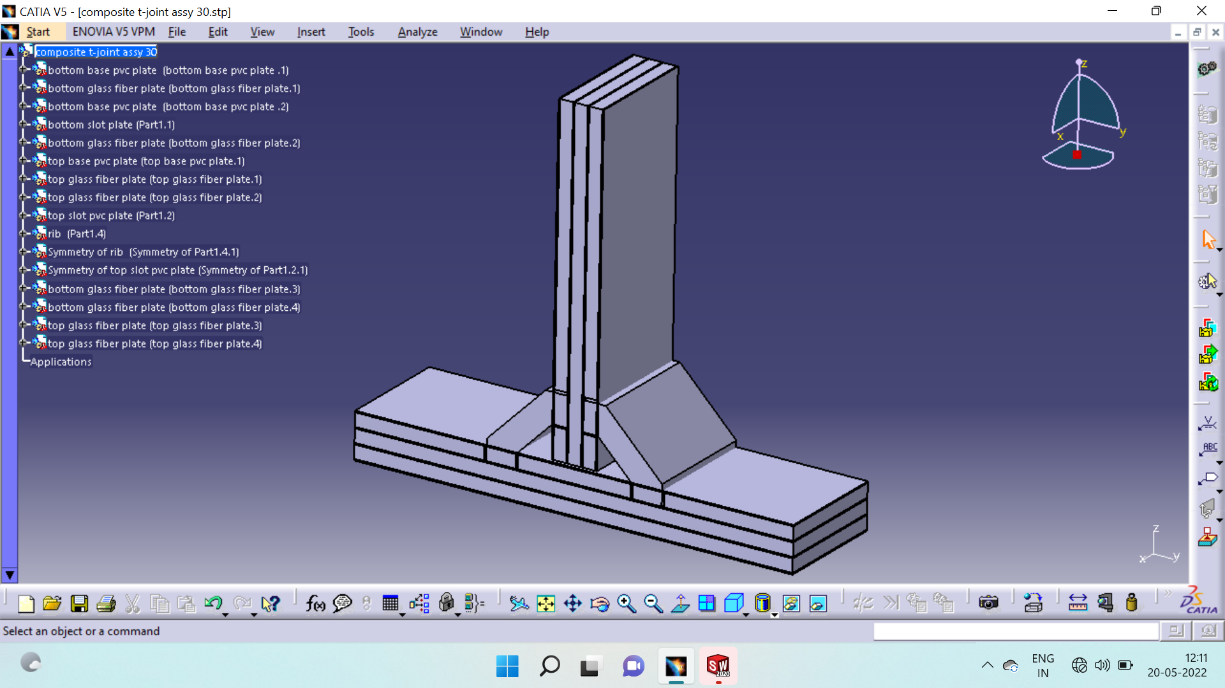

*Fig1.1 3D model of composite T-joint in CATIA V5 60 deg.*

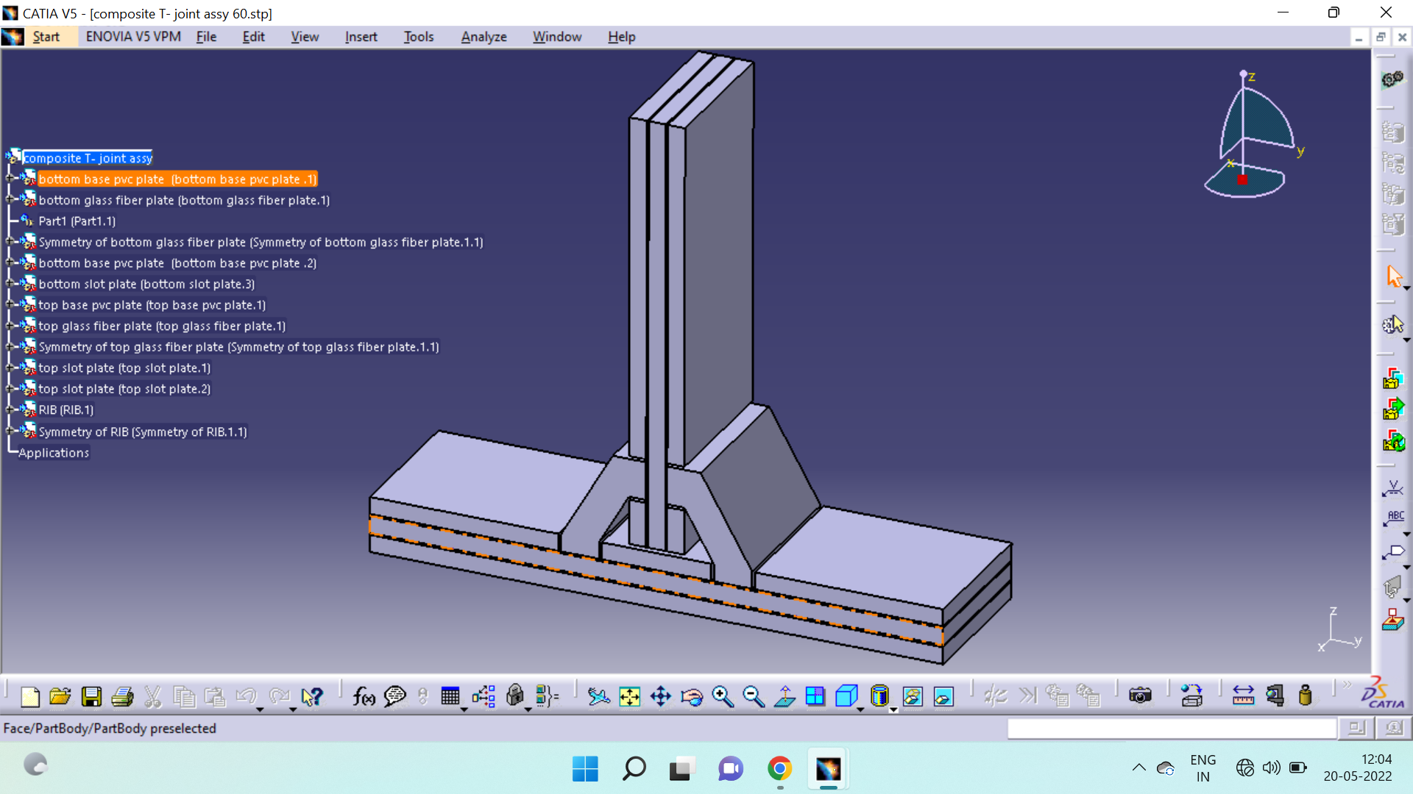

*Fig1.2 3D model of composite T-joint in CATIA V5 45 deg.*

Above Fig1.1 shows a typical t-joint used in naval ships. It consists of horizontal base panel, a vertical leg panel, and fillet and over laminates. The purpose of the fillet is to provide the continuity of the load transfer between the base panel and the leg. The over laminate is used to enhance the capacity of the T-joint. Reduction of the weight and increase the strength of the T-joint is one of the objectives. T-joint is used in between hull and bulkhead part in the naval ship.

The purpose of the project is to determine the methodology to predict the damage criticality of a composite marine structure T-joint. This knowledge will enable the prediction of the life and reliability of the structure. To acquire this, it is very useful to do the preliminary design using a FE package. The FE tool has been proved useful in predicting the behavior of composite structures. It allows for cost savings by reducing the amount of required experimental works. The FE prediction methodology is very commonly used on composite structures for not only marine structures but also for aerospace applications.

Since last decade, with the advent of powerful finite element analysis (FEA) packages, these have been proven good tool to perform accurate stress analysis. The geometry of composite T-joint is complicated and analysis is comparatively difficult. Optimized meshing and accurate simulation of boundary conditions along with ability to apply complex load, provided by various FEM packages has helped the designer to carry out analysis with the investigation of critical stresses. FEM enables to find critical locations and quantitative analysis of the stress distribution and deformed shapes under loads. However detailed modeling and specialized Knowledge of FEM theory is indispensable to perform these analyses with high accuracy. It also requires complicated meshing strategies. Simulations of actual boundary conditions to equivalent FE boundary conditions have to be done carefully because a wrongly modeled boundary condition leads to erroneous results. The solution of such large scale FEM problem requires both large memory and disc space as computing resources.

The main motivation behind the work was to go for complete FEA of T-joint with different materials for skin, core and filler. By performing structural analysis of skin, core, filler etc at different loads, overall deflection and stresses are studied.

* 1. **PROBLEM STATEMENT:**

The objective of the project is to manufacture the T-joints and perform static tensile tests on them. The strength and failure mode will be studied experimentally and by finite element analysis. Load vs. displacement curves will be plotted.

* 1. **OBJECTIVE**

The aim can be broken down into the following task-oriented objectives:

* To determine the methodology to predict the damage critically of a composite marine structure.
* To develop T-joint in naval ship super structure over traditional T-joint.
* Strengthen a traditional hull- bulkhead T-joint by new techniques.
* To bring use of composite material into focus.
* To suggest use of composite T-joint in not only marine but in day-by-day usage like trusses, building structures etc.

**1.2.1 FEM WORK:**

The commercial finite element package ANYSYS 12 will be used to analyze T-joint under tensile loading.

1. T-joint model will be created using CAD software CATIA V5R17.
2. A method for a finite element (FE) parameter study will be developed using available software like ANSYS 12 and used for selection of promising (strong) configuration of T-joint.
3. Geometry and materials for lightweight sandwich T-joint will be optimized for tensile loading using FE Analysis by performing Structural static analysis in the ANYSYS 12.

The results of the experimental tensile tests will be compared with the FE analysis results for the various specimens.

**1.2.2 Expirimental Work:**

1. As shown in fig. 1.1 T- Joints of composite materials will be manufactured.
2. The static tensile test is performed on a Servo hydraulic testing machine at a constant cross-head speed.
3. Load cells and LVDT gauges will be used for measurement of load and displacement respectively.
4. Load vs. displacement curves will be plotted.
5. Failure stress will be measured for Three T joint specimens.
6. Two different configurations each consisting of three similar T joint specimens will be compared on the basis of relative stresses in the different parts of the joint.

**1.2.3 COMPARISON AND VERIFICATION BY FEM**

The results of the experimental tensile tests will be compared with the FE Analysis results for the various specimens.

1. A comparison of the load vs. displacement curve for static tensile test between FEA and experimental data.
2. The different joint configurations will be compared on the basis of relative

stresses in the different parts of the joint.

The relative stresses will be defined as stresses divided by the relevant strength (σx/X, σY/Y and σxy/S) in the direction, X along the base panel (panel A), in the direction Y, along the T-panel (panel B).

**1.3 COMPOSITE STRUCTURE OF T JOINT**

Composite structures are made for the combination of more than one material in order to achieve the required properties for specific applications. These are three types of Composite depending on the types of reinforcement used; metal-matrix composites, fiber reinforced polymers (FRP) and particulate composites. However, FRP composite are used most widely.

|  |  |  |  |  |  |  |
| --- | --- | --- | --- | --- | --- | --- |
| Sr.No. | Part Name | Materials | Dimensions | Value (mm) | Quantity | Shape |
| 1 | T-Joint | See below | Overall width | 160 | - |  |
| Overall length | 600 |
| Overall height | 660 |
| 2 | Triangular Fillets | PVC Foam | Base length | 120 | 2 |  |
| Height | 103.92 |
| Angle of base | 450,600 |
| 3 | Skin laminates | Glass Fiber | Thickness | 2 | 4 |  |
| 4 | Core A and B | PVC Foam | Thickness | 18 | 3 |  |
| 5 | Filler | Epoxy Resin  520 | Thickness around the fillet | 3 | - | Liquid |

*Table 1: Materials and specification of the T-joint.*

**1.3.1 FUNCTIONS OF T JOINT:**

For a hull structure with a number of compartments, a typical joint, known as a T-Joint is used to join the hull and bulkhead sections (see Figure 1.1). It consists of composite over laminates over a shaped fillet constructed by stacking up layers of laminates through hand-lay-up process. Filler made from chopped fiber reinforced resin is used to form the fillet. The function of the T-Joint is to transfer flexural, tensile and shear loads between the hull and bulkhead and to maintain watertight integrity between compartments separated by the bulkhead.

There are two types of T-Joints depending on the over laminates shape. They are triangular and circular T-Joints. Unlike triangular T-Joints, much research has been done for circular T-Joints. The over laminates and the resin filler in the fillet are the load transmission path between the hull and bulkhead. Hence, the strength of the joints depends on the strength of both parts stated that there were two load conditions experienced by T-Joints. The first condition was the compression at the interface between hull and the over laminates due to hull pressure. The second one was the tension at the same interface due to heavy machinery’s weight. In addition, over laminate can be the main source of delaminating due to the variable quality of the interfaces and the presence of defects. The hull and bulkhead are the primary structures in maintaining the ship stiffness under various loadings.

Therefore, their reliability depends mainly on the T-Joint as the connection between both structures. Since a T-Joint is a bonded connection, it is the weakest link by nature.

Its weaknesses are attributed to the following conditions:

1. There is no load bearing fibers in the bonded interface.

2. The resin used to bond the interface has low strength under tensile and shear

Stresses.

3. The occurrence of stress concentrations due to structural geometric irregularities

and manufacturing flaws.

4. The tendency of the bond to peel when imperfections grow and propagate under

load.

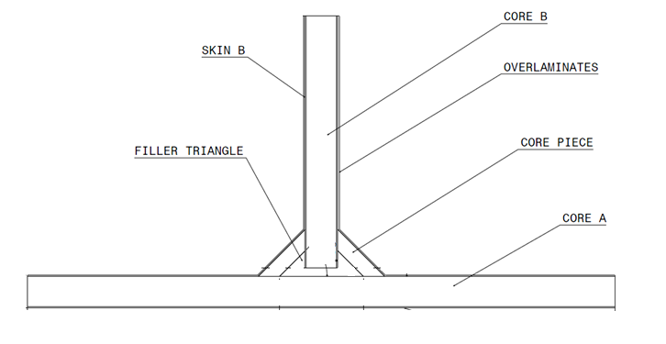

*Basic Dig. Of T-Joint*

**1.3.2 ORGANIZATION OF DISSERTATION**

INTRODUCTION

LITERATURE REVIEW

SOLID MODELLINGOF COMPOSITE T JOINT

FINITE ELEMENT ANALYSIS

MATERIAL SELECTION

DESIGN OF COMPOSITE T JOINT

MANUFACTURING OF T JOINT

EXPERIMENTAL STRESS

MANUFACTURING OF T JOINT

EXPERIMENTAL STRESS ANALYSIS

ANALYSIS OF T JOINT

RESULTS AND DISCUSSION

CONCLUSION

FUTURE SCOPE

**CHAPTER 2.**

**LITERATURE REVIEW**

**2.1 LITERATURE SURVEY**

T-joints are used in naval ships. The function of the T-Joint is to transfer flexural, tensile and shear loads between the hull and bulkhead. Many researchers have studied T-Joints with respect to static, dynamic, fatigue loading conditions and Tensile, compressive, flexural tests on composite T-joint. Further progressive failure of these joints is also topic of research. There are many research papers devoted to FEA analysis of these joints using software’s like ANSYS, ABAQUS and LS-Dyna etc. Experimental verification of ANSYS results has been also undertaken by many of them.

Following is a brief review of the literature concerned with analysis of Composite T Joint in Tabular format:

|  |  |  |  |
| --- | --- | --- | --- |
| REFERANCE | MAIN PURPOSE OF STUDY | CRITERIA CONSIDERED | REMARK |
| Uday S. Dixit | Finite element method (FEM) is a numerical method for solving a differential or integral equation | While using the finite element method is illustrated with the help of the plane stress and plane strain formulation. | Introduction to finite element method and finite element formulation of plane stress and plane strain problems has been described. |
| Nguyen Viet Hung, Thai The Hung, Luu Quang Thin, Bui Tran Trung, Luu Chi Hieu | Finite Element Analysis for Various Structures Made of Classic and Composite Material by Using ANSYS Software | Results obtain over a deep forming process of a double sink, a stadium roof under the wind effect, and a ferro-concrete beam reinforced by Carbon Fiber Reinforced Polymer (CFRP) strips. | In this paper, the three simulations for three different cases were represented. The usefulness and powerfulness of CAE software, namely the ANSYS software is proven. |
| Moon Kyu Lee , Hyungyil Lee, Tae Soo Lee , Hoon Jang | Buckling sensitivity of a connecting rod to the shank sectional area reduction | First presents an evaluation procedure for the buckling of a connecting rod with the help of finite element analysis. The buckling stresses from the recommend FEA view point are closer to those measured in rig experiments | weight reduction of connection rod shank is tried, buckling should be regarded as an essential factor together with the other basis such as yield and fatigue |
| Jin Dai, H. Thomas Hahn | Static and fatigue behavior of vacuum assisted resin transfer molding sandwich panels under flexural loading. | Stresses in the face and core at failure where calculated from failure loads, for short beams core failure lead to failure of beam as whole, in long beams failure of wood core would be contained until the face failed. | A good similarity was seen between the static and fatigue failure modes for both short span and long span specimens. |

|  |  |  |  |
| --- | --- | --- | --- |
| REFERANCE | MAIN PURPOSE OF STUDY | CRITERIA CONSIDERED | REMARK |
| A.Groves, A. Lystrup, D.McGeorge, H.Van Aanhold | To evaluate joints suitable for use with large composite superstructures | Test procedures have been developed using both shock table facilities and conventional servo-hydraulic test machines. | The joint failed within the interface between the base sandwich laminate and the joint overlaminate. |
| Mr. Lampen, Diehl Service Modules GmbH | Experimentation on composite honeycomb sandwich t-joint connections. To understand the effect of loading and ageing on the adhesively bonded joints. | comparison of failure behavior between original and aged specimen. A fractographic analysis is performed. 3D finite element analyses is done using a cohesive element technique. | An appropriate usage of the honeycomb sandwich composites in aerospace applications requires a better knowledge of their properties and their mechanical behavior under loading and various environmental conditions. |
| Aaron Holmberg | the study is done to find the deforming force in shear load & locking angle at which S.F. increases rapidly, which helps in predicting drapability of carbon & glass fabric. | A fixture was designed to clamp the fabric & help determine the lock angle and force vs. fiber angle of fabrics. Even force distribution | Fixture proves to have potential 0-90 woven fiber, Variation of lock angle results relative to fabric tension, louvers observed near clamp surfaces may lead to uncertainity |
| John Summerscales | To study various materials and mark the core materials for sandwich panel. | Properties of composite materails and alternative technologies (3D glass fabric, bulker mats) are discussed | Alternative technology (Lantor) helps to build laminate thichness quickly, reduced resin & glass usage hence save both weight & labour |

**2.1.1 OUTCOMES OF LITERATURE REVIEW**

According to present theories and practices, we can conclude composite T-joint used in naval ship to improve the life of ship. The following outcomes can be drawn from the literature review of the composite T-joint.

1. T-joint is used to develop improved fiber composite joints for naval ship super structure.
2. The performance of the T-joint depends on fillet geometry and core material of sandwich panels. Calculate ultimate strength of the T-joint in each case by modeling and also calculate Adhesive failure and core shear failure of the sandwich panels.
3. To determine the methodology to predict the damage critically of a composite marine structure. Advanced composite materials on large ships have the potential to reduce fabrication and maintenance costs, enhance styling, reduce outfit weight and increase reliability.
4. T-joint can be very useful to extend life of naval ship due to their strength.

We have to draw the stress verses deflection graph and compared with ANSYS results.

**Chapter 3:**

**SOLID MODELING OF COMPOSITE T-JOINT**

To carry out FEM analysis of any component, the solid model of the same is essential. It is also called body in white. So the solid model of composite T-joint is require and this can be done in special CAD package like CATIA, Pro- E, Wildfire, Uni-graphics (UG), etc.

**3.1 Solid Modeling methods**

Following are the ways in which the solid model may be created.

**3.1.1 CSG** (Constructive Solid Geometry):

It is the constructive solid geometry process. In this case final model consists of union of various primitive objects such as brick, cube, sphere, cone, cylinder, etc. Depending upon the shape of final model Boolean operation is performed over these shapes to obtain the required geometry of solid model. Thus it builds a solid model from fundamental shapes.

**3.1.2** **B-REP (**Boundary Representation)**:**

It is the boundary representation of solid objects. In this case final model is only represented by its boundary surfaces. The relations between surfaces are maintained so as to give required solid model. It is a quick process. This is used to get outer surface for auto mesh.

**3.1.3 FBM (**Feature Based Modeling)**:**

It is a feature based modeling. The features such as extrude, cut, revolve, copy, etc. are used to build a solid model. Many CAD packages use FBM method. It is easy and gives ‘model tree’ for completed part, so that modification at any point at any branch can be passed through whole model. Thus FBM is suited for parameterization of model. It will be helpful to generate similar models from existing one just by changing the parameter values.

**3.2 Building Clean Geometry**

In short, clean geometry can be defined as a solid CAD model that maximizes the possibility for mesh which in turn captures the features required for correct results. Two key points are made in this statement. First, the geometric features must not prevent the mesh from being created and must also contain surfaces of consistent size and shape ratios to prevent forcing high, aspect ratio elements and/or transitions between element edges that may compromise accuracy. Second, simplification or manipulation of features in an attempt to clean up the geometry should not reduce the structural integrity of the part. The best mesh is the smallest model that yields correct data. Consequently, manipulation of the model, either by adjusting dimensions or suppressing features far from any area of interest, is acceptable as effects local to the simplification will most likely not affect the global behavior of the system. However, care should be taken when adjusting a model near an area of concern.

**



*Fig.3.2 3D model of composite T-joint in CATIA V5*

We are making T-joint with the help of following procedure in CATIA V5.

**3.2.1 Sketcher**

We are used sketcher tool to sketch the T-joint. Sketcher consists of different commands like profile, rectangle, line, axis, trim, corner, chamfer etc.

**3.2 2 Part design**

Before going on part design we need to exit workbench. After completion of sketch we used pad command to creating a pad by extruding an open or closed profile. Pad consists of different commands like as drafted filter pad, multi-pad, shaft, groove etc. We used pocket command to create pocket by removing material.

**3.2.3 Assembly Design**

For assembly design we used the constraint tool. It consists of different constraint like coincidence constraint, contact constraint, offset constraint, fix component, quick constraint etc. We used contact constraint to make assembly of T-joint.

**Chapter 4:**

**FINITE ELEMENT ANALYSIS**

**4.1 FEM Approach**

It is not always possible to obtain the exact analytical solution at any location in the body, especially for those elements having complex shapes or geometries. Here is Always matters of the boundary conditions and material properties. In such cases, the analytical solution that satisfies the governing equation or gives extreme values for the governing functional is difficult to obtain. Hence for most of the practical problems, the engineers resort to numerical methods like the finite element method to obtain approximate but most probable solutions.

Finite element procedures are at present very widely used in engineering analysis. The procedures are employed extensively in the analysis of solids and structures and of heat transfer and fluids, and indeed, finite element methods are useful in virtually every field of engineering analysis.

**4.2 Description of the method**

In any analysis we always select a mathematical model of a physical problem, and then we solve that model. Although the finite element method is employed to solve very complex mathematical models, but it is important to realize that the finite element solution can never give more information than that contained in the mathematical model.

**4.3 Physical problems, mathematical models, and the finite element solution**

The physical problem typically involves an actual structure or structural component subjected to certain loads. The idealization of the physical problem to a mathematical model requires certain assumptions that together lead to differential equations governing the mathematical model. The finite element analysis solves this mathematical model. Since the finite element solution technique is a numerical procedure, it is necessary to access the solution accuracy. If the accuracy criteria are not met, the numerical solution has to be repeated with refined solution parameters (such as finer meshes) until a sufficient accuracy is reached. It is clear that the finite element solution will solve only the selected mathematical model and that all assumptions in this model will be reflected in the predicted response. Hence, the choice of an appropriate mathematical model is crucial and completely determines the insight into the actual physical problem that we obtain by the analysis.

The key step in engineering analysis is therefore choosing appropriate mathematical models. These models will clearly be selected depending on what phenomena are to be predicted.

**4.4 Steps followed in FEA:**

In early stage of industrial applications of Finite Element Analysis, CAD, Meshing and analysis all, used to be carried out by a single engineer only. Soon it was realized that separation of the jobs and forming dedicated subgroups i.e CAD group, Meshing group and Analysis or calculation group is necessary for optimum output and efficiency.

The three important steps in ANSYS programming are:

* + 1. **Preprocessing**

This phase consists of making available the input data such as geometry, material properties, meshing of the model, boundary conditions.

* + 1. **Solution**

After reviewing the summery information about the model start the solution. When this command is issued, the ANSYS program takes model and loading information from database and calculates the results

* + 1. **Postprocessing**

Once the solution is completed successfully, the ANSYS postprocessors can be used to view the results. This is the phase where the results are viewed for the analysis done, by obtaining graphic displays, vector-plots and tabular reports of stress and displacement, etc.

**4.5.1** **CAD data**: The model may be built parametrically or a model from other software package can be imported. There are specialized software’s for preparing geometry like CATIA, UG etc.

We create 2D model in CATIA and import this model in ANSYS for analysis.

**4.5.2** **Material Properties:** - Material properties are required for most element types. Depending on the applications material properties may be linear or non-linear, isotropic, orthotropic or anisotropic, constant temperature or temperature dependent [12].

We used here orthotropic material properties. Orthotropic materials have properties that are different in three mutually perpendicular directions. The elastic constants Ex, EY, Gxy, Vxy in the local coordinates system are given together with the tensile strength X and Y in the local X and Y direction respectively. The material are assumed to be linear elastic and either orthotropic or isotropic.

**Table2:- Material properties for each part in various configurations.**

|  |  |  |  |  |  |  |
| --- | --- | --- | --- | --- | --- | --- |
| Part  No. | Part description | Material description | EX  (MPa) | EY  (MPa) | Gxy  (MPa) | Vxy |
| 1 | Skin | Glass fiber | 26,100 | 11,500 | 4,400 | 0.14 |
| 2 | Hull and Bulkhead | PVC Foam | 104 | 104 | 40 | 0.3 |
| 3 | Filler | Epoxy Resin 520 | 500 | 500 | 170 | 0.47 |

**4.5.3** **Meshing**: - FEA is to make calculations at only limited (Finite) number of points and then interpolate the results for entire domain (surface or volume).Any continuous object has infinite degree of freedom and it is not possible to solve the problems in this format.FEA reduces degree of freedom from infinite to finite with the help of discretization i.e. Meshing (Nodes and Elements) [13].

**4.5.4 Mesh Generation**

After validation of the model next step is generation of Finite Element Mesh. A very fine mesh creates the hardware space problem because the computations. As the number of nodes increases, the total degree of freedom of the model increases. Hence a designer has to model it optimally i.e. placing fine mesh only at critical area and coarse mesh at other. So that run times less and also the accuracy is not much affected.

**4.5.5** [**PLANE82**](http://www.ansys.stuba.sk/html/elem_55/chapter4/ES4-82.htm) **Element Description**

Plane 82 is a higher order version of the two-dimensional, four-node element. It provides more accurate results for mixed (quadrilateral-triangular) automatic meshes and can tolerate irregular shapes without as much loss of accuracy. The 8-node elements have compatible displacement shapes and are well suited to model curved boundaries.

The 8-node element is defined by eight nodes having two degrees of freedom at each node: translations in the nodal x and y directions. The element may be used as a plane element or as an axisymmetric element. The element has plasticity, creep, swelling, stress stiffening, large deflection, and large strain capabilities.

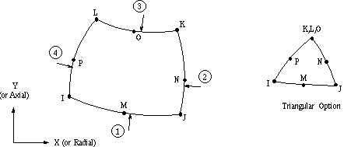

Fig Plane 82 elements

**4.5.6 Free or Mapped Mesh**

Before meshing the model, and even before building the model, it is important to think about whether a free mesh or mapped mesh is appropriate for the analysis. A free mesh has no restrictions in terms of element shapes, and has no specified pattern applied to it. A mapped mesh is restricted in terms of the element shape. A mapped area mesh contains either only quadrilateral or only triangular elements, while a mapped volume mesh contains only hexahedron elements. If we want this type of mesh, we must build the geometry as a series of fairly regular volume and/or areas that can accept a mapped mesh.

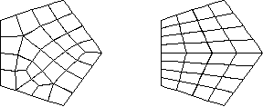Fig.4.2 Free or Mapped Mesh

Many functions included in mesh tool:

* Controlling smart sizing level
* Setting element size controls
* Specifying element shape
* Specifying meshing type(free or mapped)
* Meshing solid model entities
* Clearing meshes
* Refining meshes

Meshing is the three step procedure.

1. Define element attributes (area)
2. Specify mesh control (area)
3. Generate the mesh (free)

We used free mesh. Free mesh has no element shape restrictions. Free mesh does not follow any pattern and it is suitable for complex shape and area.

4) **Boundary Conditions:** - The word loads used here includes boundary conditions i.e. constraints, supports, externally or internally applied loads. Loads in the ANSYS program are divided into six categories: DOF constraints, forces, surface loads, body loads, inertia loads and coupled field loads. Most of these loads can be applied either on solid model (Keypoints, lines, area) or the Finite Element Model (Nodes and Elements).

After completion of preprocessing i.e. CAD, material properties, meshing and boundary conditions, software internally forms mathematical equation of the form

**[F]= [K] [δ]**

**4.6 Solution**: After reviewing the summery information about the model start the solution. When this command is issued, the ANSYS program takes model and loading information from database and calculates the results.

In this phase a solver is used to solve the basic equation for the analysis type and to compute the results. This phase is taken care by the software program. In the solution process, the solver goes through following steps to compute the solution for a steady state analysis,

1) Formulate element matrices,

2) Assembly and triangularise the overall stiffness matrix,

3) calculate the solution by back substitution,

4) Compute the stresses, displacements, etc.

**4.7 Post-processing**: Once the solution is completed successfully, the ANSYS postprocessors can be used to view the results. This is the phase where the results are viewed for the analysis done, by obtaining graphic displays, vector-plots and tabular reports of stress and displacement, etc.

**4.8 Advantages of FEA**

Increases Visualization.

Decreases design cycle time.

Decrease number of prototypes.

Reduces cost and time consuming testing.

**4.9** **Disadvantages of FEA**

Although 3D FE analysis will give more accurate results, the disadvantage is that it requires longer modeling and analysis time, hence higher costs. It is difficult, especially when many different design configurations have to be analyzed. This makes 2D FE modelling more desirable. A 2D FE model can be divided into a 2D plane-stress and plane-strain model.

**4.9.1 ANSYS**: - ANSYS is a general purpose Finite Element Analysis package for numerically solving a wide variety of mechanical problems. These problems include static/dynamic, structural analysis (both linear and non-linear), heat transfer and fluid problems, as well as acoustics and electromagnetic problems .

Fig.4.1 shows how to make structural analysis by using ANSYS. The analytical procedure is explained in following flowchart.

**Chapter 5:**

**MATERIAL SELECTION**

Composite materials, often shortened to composites or called composition materials, are engineered or naturally occurring materials made from two or more constituent materials with significantly different physical or chemical properties which remain separate and distinct at the macroscopic or microscopic scale within the finished structure.

Composites are hybrid materials made of a polymer resin reinforced by fibres, combining the high mechanical and physical performance of the fibres and the appearance, bonding and physical properties of polymers see figure 6.1. The short and discontinuous fibre composites are responsible for the biggest share of successful applications, whether measured by number of parts or quantity of material used. Less visible however, but growing enormously since the last decade, are the applications of continuous fibre reinforced polymers. Instead of mass-manufactured polymer-based products, the domain for continuous fibre reinforced composite parts is in general with advanced capital-intensive materials and products. By changing the direction of the fibres in the resin, the material properties can be tailored to the external loads. To optimise the construction multiple adjusted layers (laminate) can be used to form a laminate, see figure 5.1. Typical fibres are glass, carbon, armed and natural fibres. Epoxy, polyester & polypropylene form common resins.

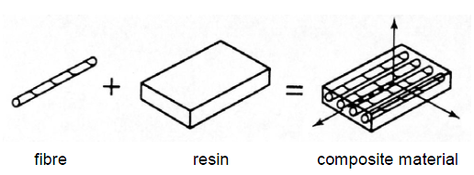

*Figure 5.1: Model of a perfectly bonded lamina*

Most commercially produced composites use a polymer Matrix material often called a reason solution there are many different Polymers available depending upon the starting raw ingredients. There are several broad categories each with numerous variations the most common known as polyester Vinylester epoxy phenolic polyimide polypropylene PEEK and others. The reinforcement materials are often fibres but also commonly ground minerals. The various methods described below have been developed to reduce the resin content of the final product, or the fibre content is increased. As a rule of thumb, Lay up results in a product containing 60% resin and 40% fibre where as vacuum infusion gives a final product with 40% and 60% fibre content. The strength of the product is greatly dependent on this ratio.

# 5.1 Resin:

EPOXY RESIN 520 / HARDENER EPOXY PAM

Epoxy resins are now used as binders in materials for construction.Generally a two-component system containing liquid epoxy resin, diluents, fillers, thickening agents, and curing agents is used. They are used to bond concrete, compositre and to produce industrial seamless thin-set terrazzo floors. This use has been extended to the laying of roads, construction of buildings, and filling cracks in concrete structures.

**Application of epoxy resin:**

Epoxy resins are used to form rigid, lightweight, foamy structures with good insulation properties. They are particularly used for foam-in-place applications in the “potting” process, as well as in casting.

Laminated epoxy insulations are largely used as sheets, rods, and tubes. Sheets of woven glass, paper, and polyaramid fabric or cotton prepregnated with the B-stage epoxy resins are laminated in large multiple pattern presses. These are used in preparing assemblies of copper-clad glass or polyaramid fibers for printed circuit boards in the electronics industry. Laminated epoxy structures are used in building construction for concrete molds, honeycomb cores, facing for foams, wood, metal assemblies, and reinforced pipes. Both wet impregnated and dry epoxy resin systems are used in aircraft construction. Carbon and polyaramid fibers are used in the laminates. Epoxy laminates also find application in marine industries; epoxy resins are replacing polyesters in special applications in which underwater strength is important.

Other thermosetting resins such as polyester and epoxy cure by mechanisms that do not produce any volatile by products and thus are much easier to process ('addition' reactions). Once cured, thermosets will not become liquid again if heated, although above a certain temperature their mechanical properties will change significantly. This temperature is known as the Glass Transition Temperature (Tg), and varies widely according to the particular resin system used, its degree of cure and whether it was mixed correctly. Above the Tg, the molecular structure of the thermoset changes from that of a rigid crystalline polymer to a more flexible, amorphous polymer. This change is reversible on cooling back below the Tg. above the Tg properties such as resin modulus (stiffness) drop sharply, and as a result the compressive and shear strength of the composite does too. Other properties such as water resistance and colour stability also reduce markedly above the resin's Tg.

Although there are many different types of resin in use in the composite industry, the majority of structural parts are made with three main types, namely polyester, vinylester and epoxy.

**5.1.1 Adhesive Properties:**

It must be understood that the adhesive properties of a resin system is important in achieving the full mechanical properties of a composite. The adhesion of the resin matrix to the fibre reinforcement or to a core material in a sandwich construction is important. Of the three resin types discussed in the article (polyester, vinyl ester and epoxy resin) polyester resins generally have the lowest adhesive properties of the three systems. Vinyl ester resin shows improved adhesive properties over polyester but epoxy systems offer the best performance of all, and are therefore frequently found in many high-strength adhesives. This is due to their chemical composition and the presence of polar hydroxyl and ether groups. As epoxies cure with low shrinkage the various surface contacts set up between the liquid resin and the adherents are not disturbed during the cure. The adhesive properties of epoxy are especially useful in the construction of honeycomb-cored laminates where the small bonding surface area means that maximum adhesion is required. The strength of the bond between resin and fibre is not solely dependent on the adhesive properties of the resin system but is also affected by the surface coating on the reinforcement fibres.

**5.1.2 Mechanical Properties:**

Two important mechanical properties of any resin system are its tensile strength and stiffness. Figures 5.2 show results for tests carried out on commercially available polyester, vinyl ester and epoxy resin systems cured at 20°C and 80°C. After a cure period of seven days at room temperature it can be seen that a typical epoxy will have higher properties than a typical polyester and vinyl ester for both strength and stiffness. The beneficial effect of a post cure at 80°C for five hours can also be seen.

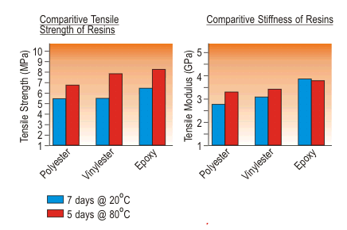

*Figure 5.2: Comparative Tensile Strength and Stiffness of Resins*

Also of importance to the composite designer and builder is the amount of shrinkage that occurs in a resin during and following its cure period. Shrinkage is due to the resin molecules rearranging and re-orientating themselves in the liquid and semi-gelled phase. Polyester and vinyl esters require considerable molecular rearrangement to reach their cured state and can show shrinkage of up to 8%. The different nature of the epoxy reaction, however, leads to very little rearrangement and with no volatile by-products being evolved; typical shrinkage of an epoxy is reduced to around 2%. The absence of shrinkage is, in part, responsible for the improved mechanical properties of epoxies over polyester, as shrinkage is associated with built-in stresses that can weaken the material. Furthermore, shrinkage through the thickness of a laminate leads to ‘print-through’ of the pattern of the reinforcing fibres, a cosmetic defect that is difficult and expensive to eliminates.

**5.3 Fiberglass:**

Fiberglass is a lightweight, extremely strong, and robust material. Although strength properties are somewhat lower than carbon fiber and it is less stiff, the material is typically far less brittle, and the raw materials are much less expensive. Its bulk strength and weight properties are also very favorable when compared to metals, and it can be easily formed using molding processes.

The plastic matrix may be epoxy, a thermosetting plastic (most often polyester or vinylester) or thermoplastic. Common uses of fiberglass include boats, automobiles, baths, hot tubs, water tanks, roofing, pipes, cladding, casts and external door skins. An individual structural glass fiber is both stiff and strong in tension and compression that is, along its axis.

Fiberglass is an immensely versatile material which combines its light weight with an inherent strength to provide a weather resistant finish, with a variety of surface textures.

The development of fiber reinforced plastic for commercial use was being extensively researched in the 1930s. It was particularly of interest to the aviation industry. Its first main civilian application was for building of boats and sports car bodies, where it gained acceptance in the 1950s.



*Figure 5.5: A general plain weave fabric lamina*

# 5.4 Foam Cores:

Foams are one of the most common forms of core material. They can be manufactured from a variety of synthetic polymers including polyvinyl chloride (PVC), polystyrene (PS), polyurethane (PU), polymethacrylamide, polyetherimide (PEI) and styreneacrylonitrile (SAN). They can be supplied in densities ranging from less than 30kg/m3 to more than 300kg/m3, although the most used densities for composite structures range from 40 to 200 kg/m3. They are also available in a variety of thicknesses, typically from 5mm to 50mm.

**5.4.1 PVC Foam**

Closed-cell polyvinyl chloride (PVC) foams are one of the most commonly used core materials for the construction of high performance sandwich structures. Although strictly they are a chemical hybrid of PVC and polyurethane, they tend to be referred to simply as 'PVC foams'.

PVC foams offer a balanced combination of static and dynamic properties and good resistance to water absorption. They also have a large operating temperature range of typically -2400C to +800C,and are resistant to many chemicals. Although PVC foams are generally flammable, there are fire-retardant grades that can be used in many fire-critical applications, such as train components. When used as a core for sandwich construction with FRP skins, its reasonable resistance to styrene means that it can be used safely with polyester resins and it is therefore popular in many industries. It is normally supplied in sheet form, either plain, or grid-scored to allow easy forming to shape.

There are two main types of PVC foam: cross linked and uncross linked with the uncross linked foams sometimes being referred to as 'linear'. The uncross linked foams (such as Airex R63.80) are tougher and more flexible, and are easier to heat-form around curves. However, they have some lower mechanical properties than an equivalent density of cross-linked PVC, and a lower resistance to elevated temperatures and styrene. Their cross-linked counterparts are harder but more brittle and will produce a stiffer panel, less susceptible to softening or creeping in hot climates. Typical cross-linked PVC products include the Herex C-series of foams, Divinycell H and HT grades and Polimex Klegecell and Termanto products.

**5.4.2 Polystyrene Foams**

Although polystyrene foams are used extensively in sail and surf board manufacture, where their light weight (40kg/m3), low cost and easy to sand characteristics are of prime importance, they are rarely employed in high performance component construction because of their low mechanical properties. They cannot be used in conjunction with polyester resin systems because they will be dissolved by the styrene present in the resin.

**5.4.3 PMI (Polymethacrylimide) Foams**

For a given density, PMI (polymethacrylimide) foams such as ROHACELL offer some of the highest overall strengths and stiffness of foam cores. Their characteristics also include high dimensional stability, a closed cell structure and high fatigue life, and they can be cured and used at elevated temperatures. Their overall cost and performance characteristics mean that, to date, their use has mainly been in higher performance composite parts such as helicopter rotor blades, ailerons and stringer profiles in pressure bulkheads.

**5.4.4 Other thermoplastics**

As new techniques develop for the blowing of foams from thermoplastics, the range of expanded materials of this type continues to increase. Typical is PEI foam, an expanded polyetherimide/polyether sulphone, which combines outstanding fire performance.We have chosen the suitable material from standard journal, composite books and science direct paper. We have compared all the material properties, availability and cost of the material with other material and selected one of the good materials for making new T-joint.

**Chapter 6:**

**DESIGN OF COMPOSITE T-JOINT**

**6.1 T-joint design concept:**

According to above theories discussed in literature survey following conclusions can be made. In order to construct a new design of composite T- joint based on above theories these conditions and criteria are consider

1. Two plates either core A, B or Hull- Bulkhead assembly should be joint at 90 degree and some provision should be made to fix them at 90 degree (by groove or guide).
2. It should be a composite structure i.e. use of two or more material.
3. Over laminates or skin is provided for better strength against tension and to protect filler material in main adhesive bonding zone.
4. Minimum use of filler material or resin to make it light weight.
5. Good appearance and simplicity in handling.
6. Dimensions are round off so that manufacturing becomes easy.

From above considerations, a new T-joint can be constructed as shown in fig.

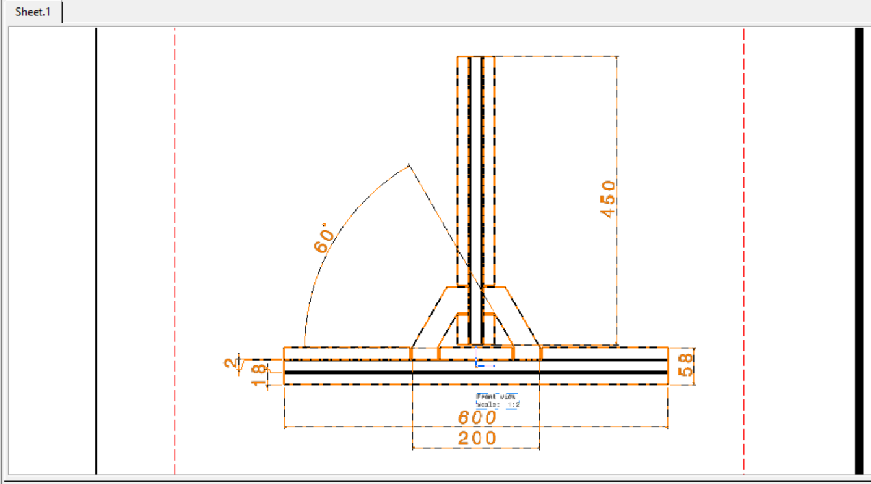

*2D drawing of T-Joint*

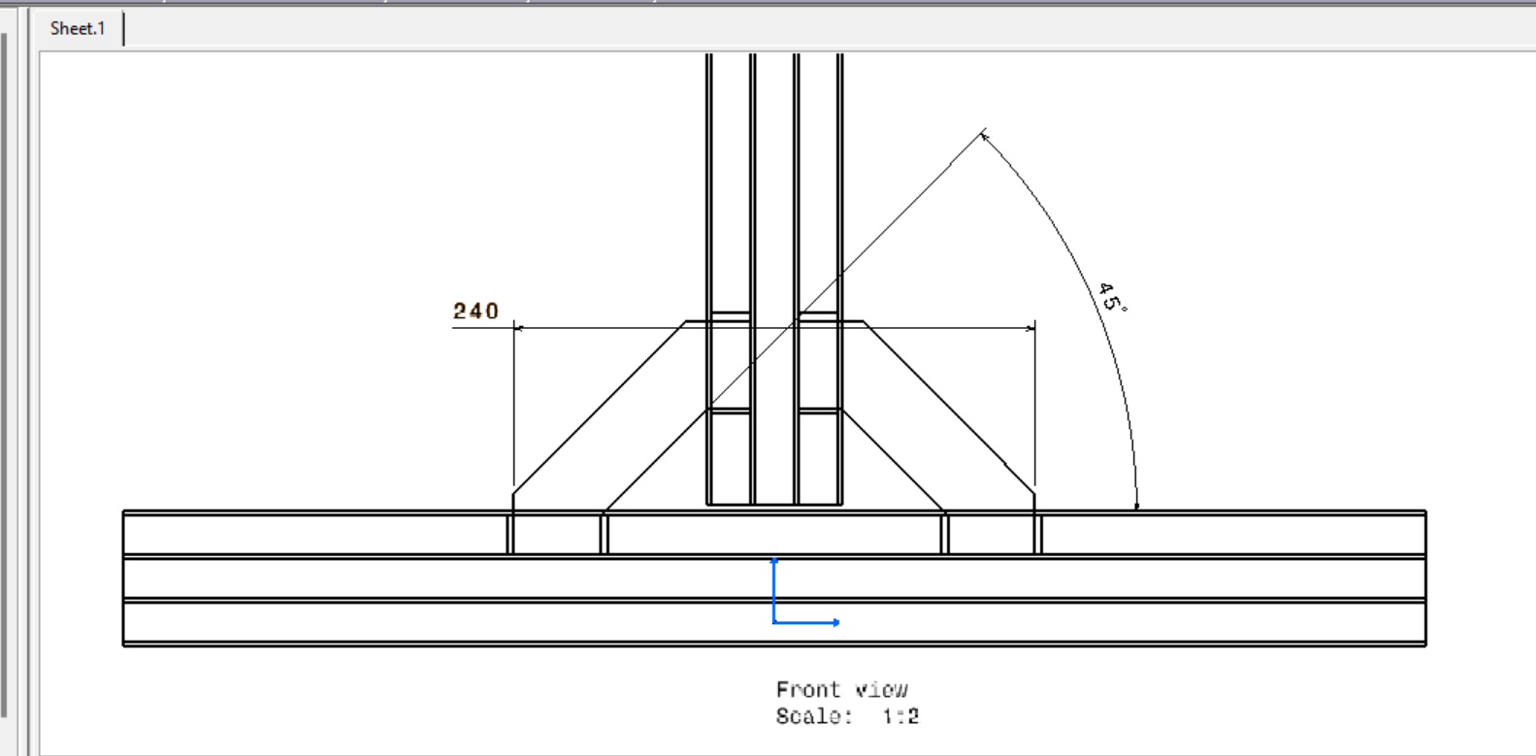

|  |  |  |  |
| --- | --- | --- | --- |
| SR. NO. | PART NAME | MATERIAL | QUANTITY |
| 1 | CORE A | PVC FOAM | 3 |
| 2 | CORE B | PVC FOAM | 3 |
| 3 | SKIN A | FIBERGLASS | 2 |
| 4 | SKIN B | FIBERGLASS | 2 |
| 5 | CORE PIECE | PVC FOAM | 3 |
| 6 | FILLER TRIANGLE | RESIN | 1 |
| 7 | OVERLAMINATE | FIBERGLASS | 2 |
| 8 | RIB | PVC FOAM | 2 |

Main features of New T-joint as follows-

1. Skin is provided to both vertical as well as horizontal plates.
2. Overlaminate covers are not only providing to vertical and horizontal plates it is also proving the main bonding zone.
3. PVC foam is used to make it light weight as a core material and has laminated with fibreglass to increase its tensile strength.
4. Supporting core pieces are used to ensure vertical plate is normal to horizontal plate.
5. Core pieces also increase the bonding surface area and protect the filler material. It is useful in minimizing the quantity of resin required for joining both plates.
6. No curvature is provided, hence simplicity in manufacturing and ease in use.
7. Complete assembly is symmetric about Y-axis.
8. Sufficient width is provided (150 mm) for more contact and cross sectional area.

In order to manufacture above composite T-joint we need PVC foam sheet of size (700X150X30) mm. Mentioned thickness here is 30 mm, but the PVC foam with 30 mm thickness is rarely used and it is not easily available in market. Maximum thickness of PVC foam sheet available is 18 mm. That’s why we have decided to modify the design. Instead of using single sheet of 30 mm thickness we’ve decided to use 2 plates of maximum thickness as 18 mm and join them by same adhesive material which is used for main filler i.e. Epoxy.

In above modification we strengthen the concept of composite material of using more than two material or constituents by introducing third element i.e. a layer of epoxy resin between PVC foam sheets. Hence our requirement of maximum thickness is fulfilled without breaking composite definition. Figure shows modified design of composite T- joint.

**6.2 3D modeling:**

This T-joint is 3D modelled in CATIA V5 R17 with proper constraints with material properties.

*Figure 6.2 3D model of composite T-joint in CATIA V5*

A 3D model of New T-joint is made in CATIA V5 R17 with all constraints. The problem in working with CATIA V5 is that, it has a limited material library. And both fiberglass and PVC foam were not present in material library. We have given all the material properties in ANSYS according to respective material.

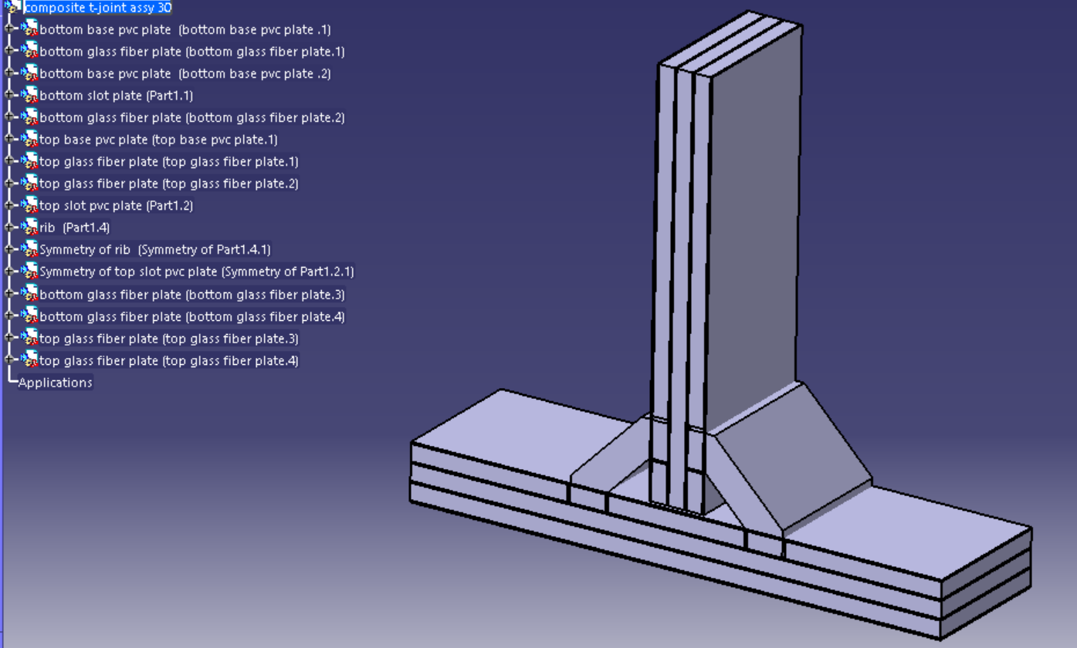

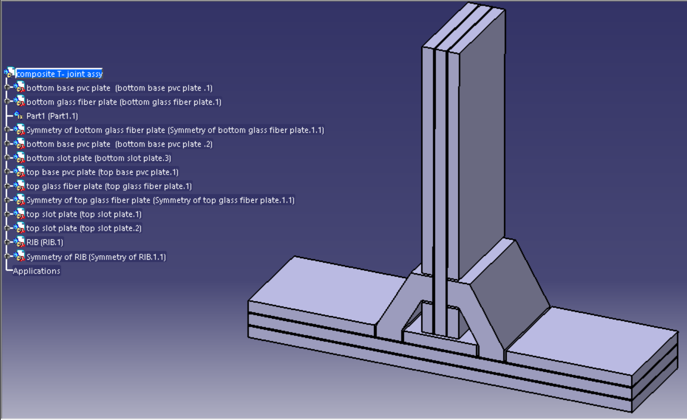

**Chapter 7:**

**Manufacturing of T-joint**

The manufacturing of T-joint will be carried out in college workshop to get guidance of workshop supervisor and project guide.

A T-joint consists of horizontal plate (hull), vertical plate (bulkhead), core pieces, filler triangle and overlaminates. Sandwich panels for T- joint are manufactured by HLU (Hand Lay-up) method. Since hull and bulkhead are made from core laminated with skin, it becomes quite difficult to understand and manufacture. Hence whole manufacturing process is simplified one by one as follows:

* 1. **Hull and Bulkhead:**

Hull and bulkhead are made of core laminated with skin. PVC foam is used as core whereas skin is made from fibreglass. PVC foam is soft and pores material can be cut easily on machine saw. It is cut according to following dimensions and quantity.

**Table 4- Dimensions and quantity of PVC foam to cut**

|  |  |  |  |
| --- | --- | --- | --- |
| LENGTH (mm) | WIDTH (mm) | THICKNESS (mm) | QUANTITY |
| 8000 | 4000 | 18 | 1 |

A surface preparation is carried out on above four plates by scratching on surfaces by blade. Uniform layer of epoxy is applied on them and attached them like a sandwich. A 600 mm and 600 mm length pieces are joined separately with epoxy and kept for solidifying. It requires 30-45 min for solidifying. Then fiberglass is cut according to above dimensions and glued to PVC foam and kept to solidify.

After solidification the remaining strings of fibreglass were cut down as shown below with the help of scissor and hex blade.

**7.2 DESIGING OF T-JOINT:**

There were three different designs manufactured with the change in angle of rib. In first design was at 30 deg angle, second structure with 45 deg and the third design had 60 deg angle of rib with horizontal. Based on the change of structure three trails were taken with each structure and the results were compared.

**2D VIEW OF COMPONENETS OF COMPOSITE T-JOINT:**

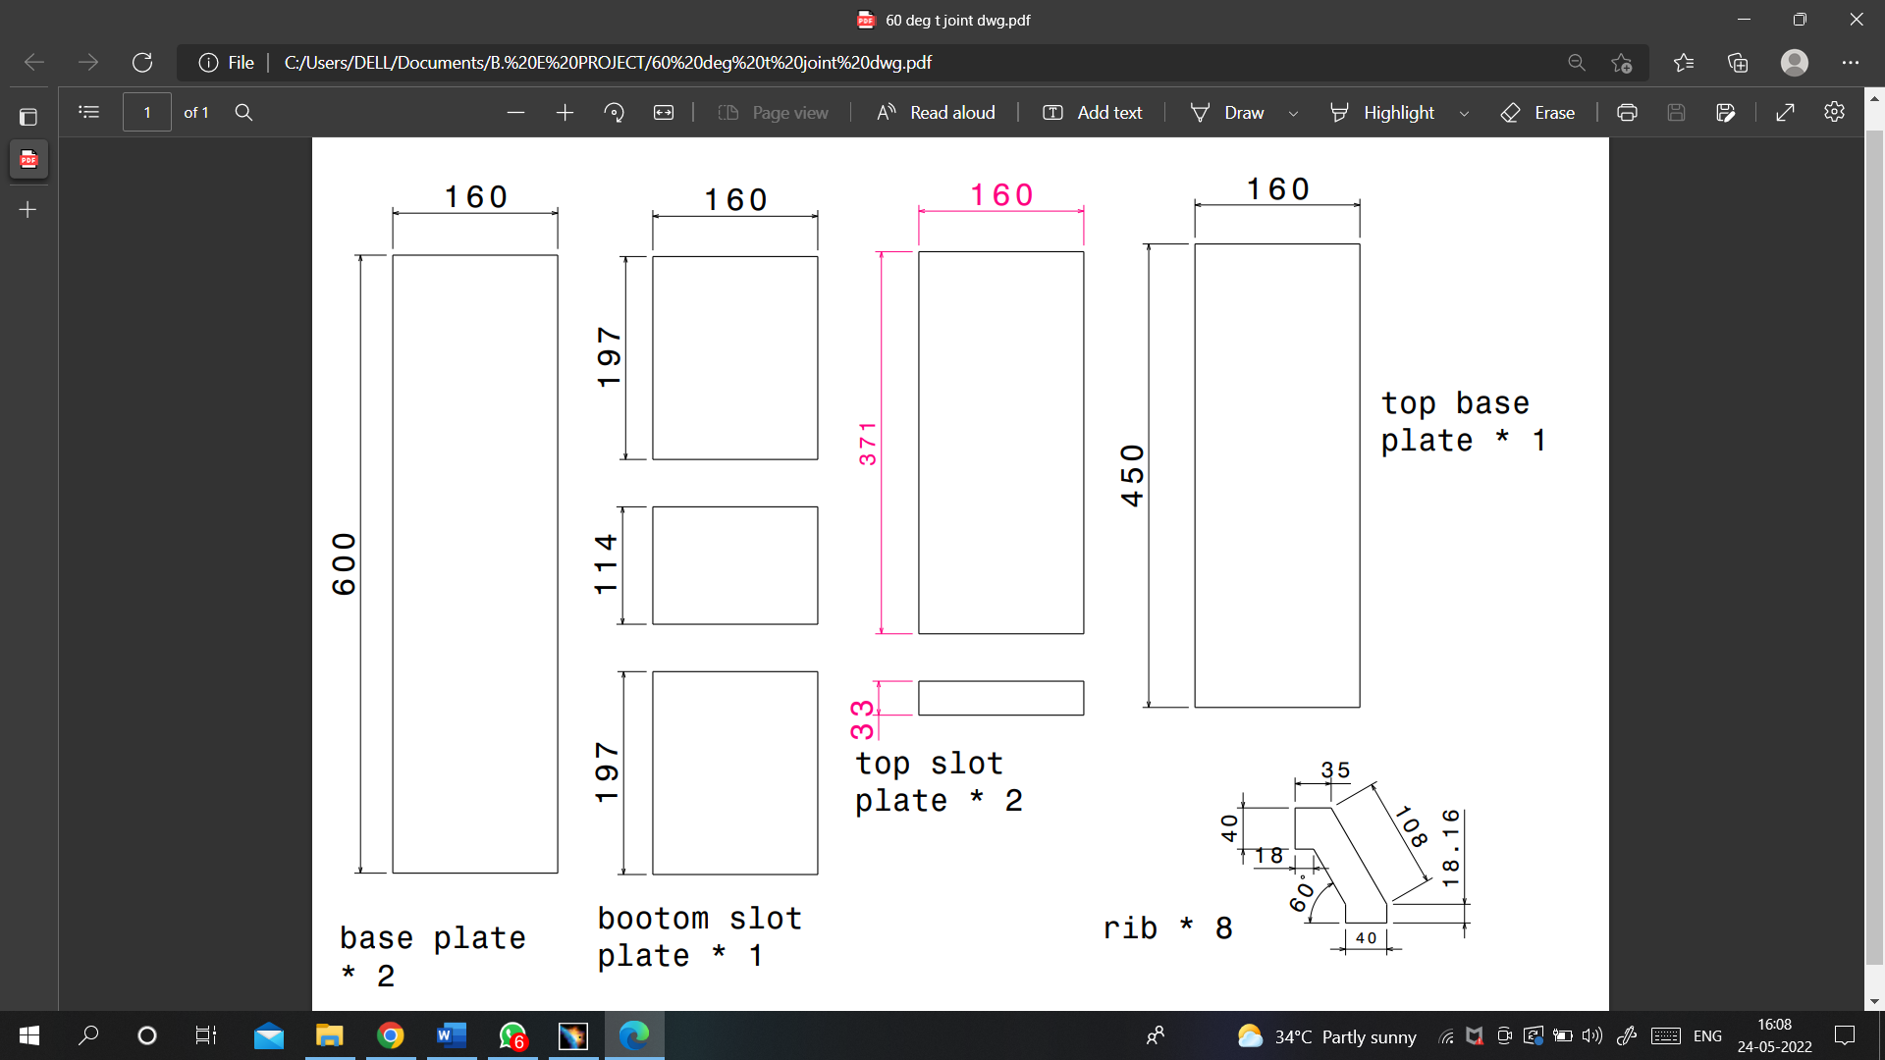

**7.3 MANUFACTURING OF T-JOINT:**

The t-joint was manufactured in college workshop under the guidance of workshop supervisor and project guide

The T-joint has horizontal plate (Hull), vertical plate (bulkhead), core pieces, filler triangle and overlaminates. Using hand lay-up technique the Sandwich panel for T-joint are manufactured.

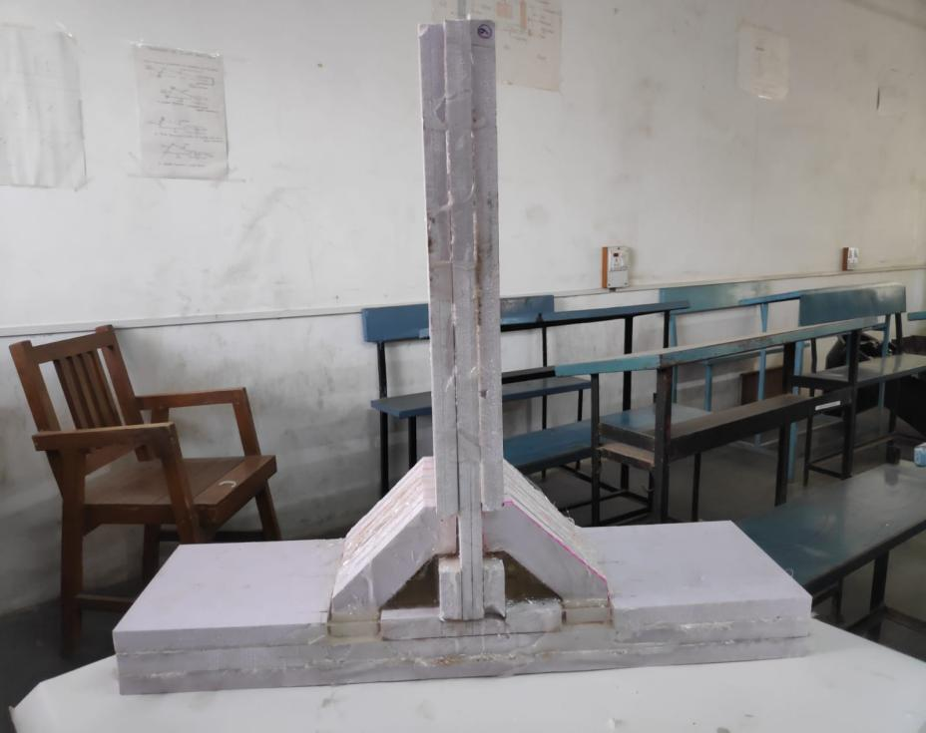

**7.4 CORE PIECES:**

Core pieces were cut according to dimensions at 45, 30 and 60 deg angle simultaneously with the help of CNC Router Machine.

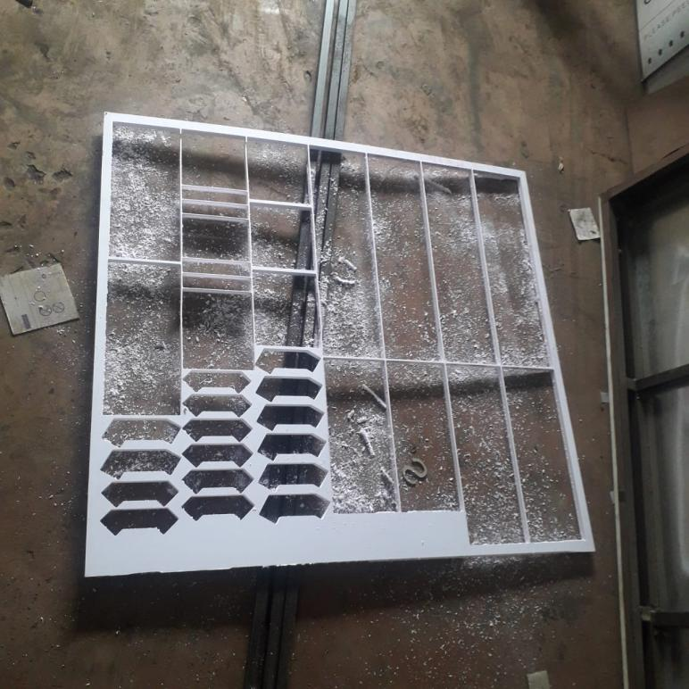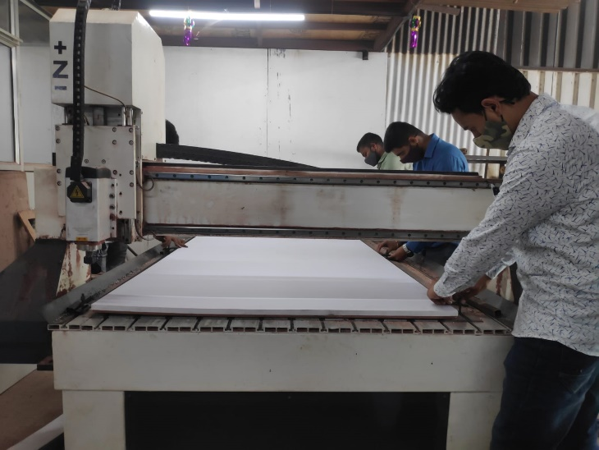

**7.5 FILLER TRIANGLE:**

Filler triangle is filled with Epoxy Resin 520 mixed with Hardener Epoxy PAM. Epoxy resin hardens after cooling and tightly holds the hull and bulkhead. The inner surfaces of core material are starched to ensure better fill up with epoxy resin.

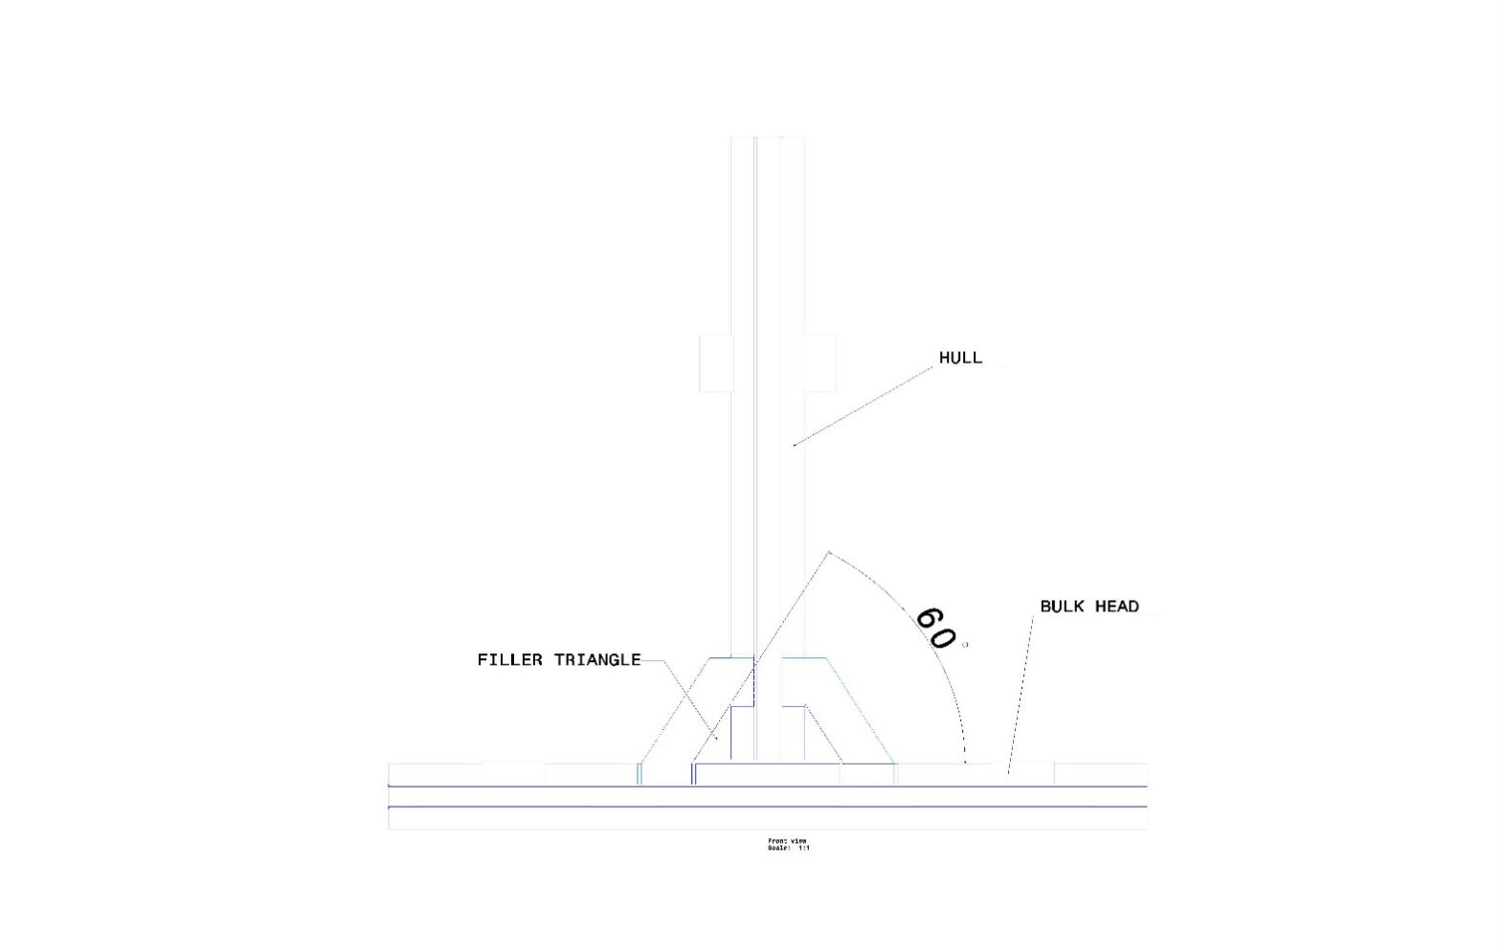

*Figure 7.2 Typical mould arrangements for filler triangle*

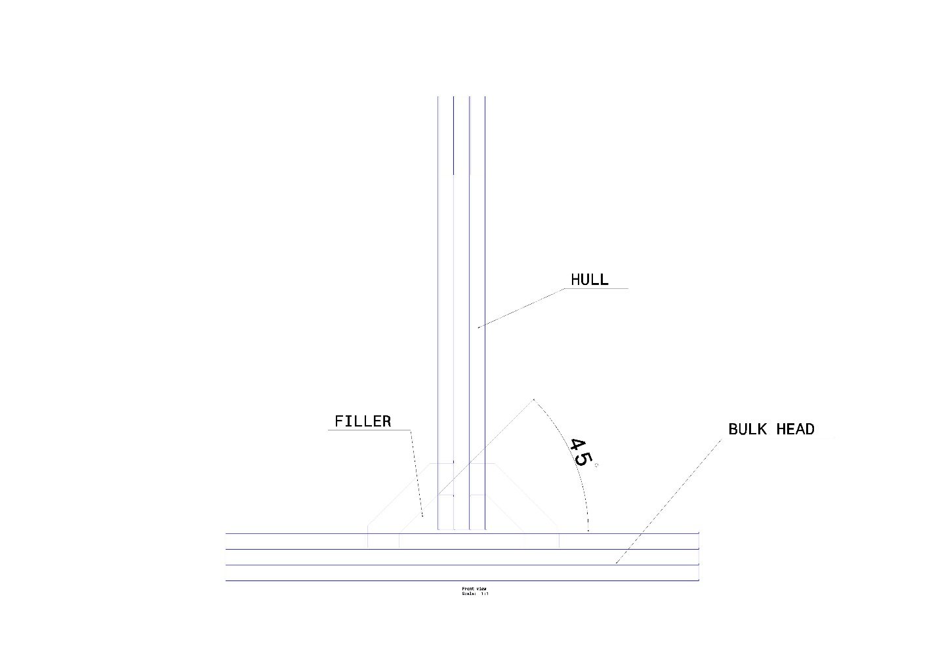

**7.6 OVERLAMINATES:**

To increase the strength of PCV foam structure, it is coated with laminate of glass fiber and epoxy resin. It is also joined by HLU method. With the help of painting roller the resin is spread on the surface of horizontal as well as vertical plates and for the adhesion of core pieces

.

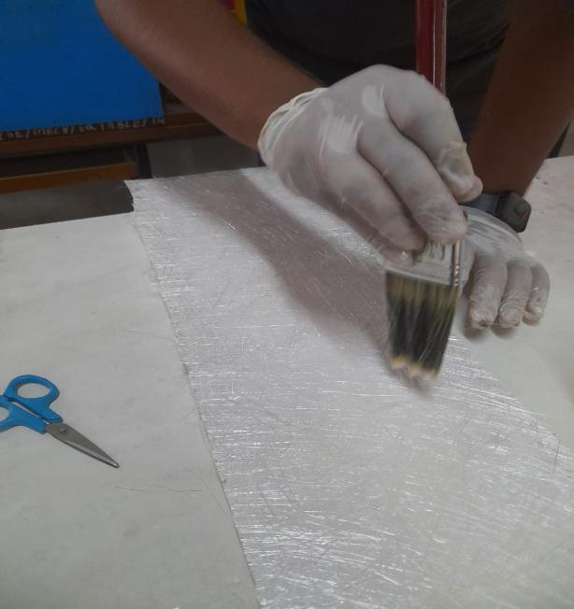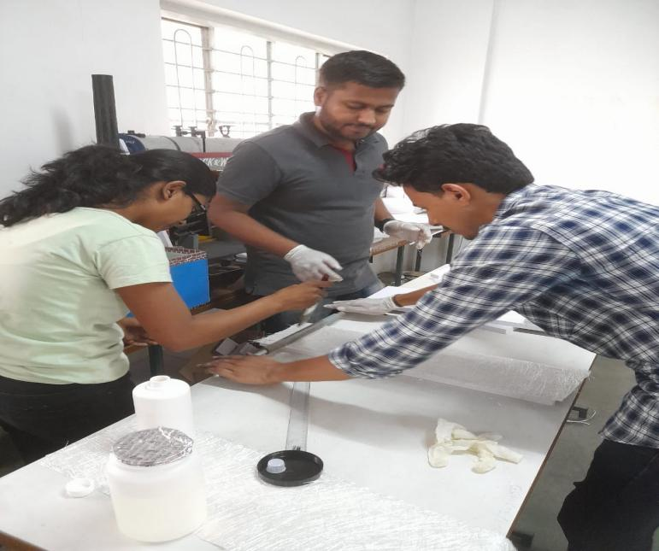

**7.7 FIXTURE MANUFACTURING:**

In order to test the T- joint on the UTM a specially designed fixture was manufactured which acted as a jaw between the structure and machine. The construction of the holding jaw was simple. The T-joint was placed between plates with 16mm drilled hole.

To manufacture fixture four M.S. plates were bolted to vertical jaw. Two holes were drilled at a distance of 50mm from top and 130mm apart. Nut bolts were used to join the M.S. plates. Holes are drilled on vertical drilling machine in college workshop. Four M.S plates are fixed and tightened with nuts and washer. M10 X 140 bolts were selected on the basis of pulling force of 2kn. M10 bolts were capable to sustain at that much load.

A finite element analysis was performed to assess the failure sensitivity to structural disbonds, which was followed by an experimental test program for the purpose of validation.

It is important to emphasize that the FE analysis presented in this work was used only to support the design of the beam experiment and to correlate the numerical strength with experimental measurements.

**7.8 JOINING METHODS:**

There is various manufacturing process for joining of T-joint. For joining of composite T- joint we have used Hand Lay-up technique.

# 7.8.1 Wet/Hand Lay-up:

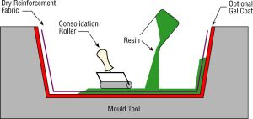

*Figure 7.5 Wet/Hand Lay-up*

**Description:**   
Resins are impregnated by hand into fibre which isthe in the form of woven, knitted, stitched or bonded fabrics. This is usually accomplished by rollers or brushes, with an increasing use of nip-roller type impregnators for forcing resin into the fabrics by means of rotating rollers and a bath of resin. Laminates are left to cure under standard atmospheric conditions

**Materials Options:**  
Resins: Any, e.g. epoxy, polyester, vinylester, phenolic.   
Fibres: Any, although heavy aramid fabrics can be hard to wet-out by hand.   
Cores: Any.PVC, Wood

**Main Advantages:**

i) Widely used for many years.   
ii) Simple principles to teach.   
iii) Low cost tooling, if room-temperature cure resins are used.   
iv) Wide choice of suppliers and material types.   
v) Higher fibre contents, and longer fibres than with spray lay-up.

**Main Disadvantages:**  
i) Health and safety considerations of resins. The lower molecular weights of hand lay-up resins generally mean that they have the potential to be more harmful than higher molecular weight products. The lower viscosity of the resins also means that they have an increased tendency to penetrate clothing etc.   
ii) Resins need to be low in viscosity to be workable by hand. This generally compromises their mechanical/thermal properties due to the need for high diluents/styrene levels.

**Typical Applications:**Standard wind-turbine blades, production boats, architectural moldings and shipping.

**Safety precautions:**

Since it is a manufacturing process which carried out in work shop, following precautions had taken while working:

1. Hand gloves were used to handle fibreglass since it contained micro glass particles which may injure to hands or skin.
2. Great care has been taken while cutting PVC foam on machine saw. Cutting is done under the inspection of workshop supervisor.
3. Direct contact of resin mixture is avoided.
4. Hand gloves were used while mixing, pouring, applying resin mixture. Since it gives permanent joint, it might harmful to human skin.
5. Direct contact of fibreglass with skin is avoided. Loose strings of fibreglass were cut down by scissor or glued with resin.
6. A large amount of heat has liberated during solidification of resin, hence contact with it avoided and has kept way from obvious reach of humans.
7. Tried to cover maximum body part while working with epoxy and fibreglass.
8. Cleaned hands and instruments after working to avoid contact with glass particles.
9. Used hand gloves and used cans were disposed off after completion of work.
10. After solidifying the fibre strings covered with resin acted as a sharp nails hence it has cut down with great care.

**Chapter 8**

**EXPERIMENTAL STRESS ANALYSIS**

**8.1** Stress Analysis

We are determining the static tensile load and displacement of a T-joint with the help of stress analysis. We have studied the strength and failure mode experimentally and by finite element analysis. Load Vs Displacement curves plotted with the help of servo hydraulic testing machine.

After building the structure, it’s good practice to verify the FEM using experimental stress analysis. We are using experimental stress analysis also FE analysis. In this case, the goal is to identify the crack an existing t-joint in order to resolve problems.

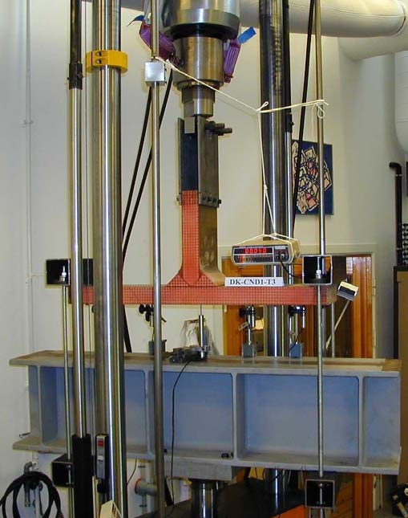

*A Typical Test rig for tensile testing of T-joint.*

**8.2** **Specification of Testing Machine**

The instruments required for the experimentation are as given below;

|  |  |
| --- | --- |
| **MODEL NUMBER** | **KIC-2-XXX-C** |
| Maximum capacity options | 50KN,75KN,100KN |
| **No.**of load cells available | Up to 16 |
| Mounting | Free stand |
| Loading test spaces | Two |
| Load accuracy | **+/-** 0.5 of reducing |
| Length accuracy | 0.1mm |
| Operating / test modes | Tensile,compression,shear,friction,flexure,bend,adhesion |
| Cross head speed | Up to 100mm/min |
| Cross head travel | 500/800 mm |
| Actuator drive | Digital AC servo drive with servo motor |
| Control mechanism | Computerized controller based with dedicated software, provides control in both auto and manual mode |
| PC configuration | Pentium IV 2.6 GHz,LCD monitor with 52x GD R/RW,256MB RAM, 40GB HDD.mouse,keybord. |
| Units | Metric,Imperial and SI User programmable. |
| Power supply | 220vac,50Hz, 500VA |
| Size | 1800(H)x750(W)X550(D)mm nominal |

**8.2.1** **Test set-up**

In the static tensile test of the T-joint, the sample is mounted to the load cell at the top of the T-panel. Bottom plate (hull) of T-joint has fixed on movable platform of hydraulic testing machine with the help of C-clamps as shown above. The fixture attached with vertical plate (bulkhead) was clamped with mechanical arrangement to upper jaw of machine. Ensured that the T-joint at machine’s center to avoid offset loading. The base of the test rig is 750mm long heavy section steel beam.

The test sample is loaded through pairs of square steel tube. Steel road are mounted in spherical bearings (SKF GX 17 F) to allow for free rotation of the test sample at the ends. The top of the T-panel is connected to the testing machine through two 10mm thick steel plates of 320 x 50 mm (H X W). The steel plates are bolted to the test sample by six M16 x 100 bolts. The top end of the steel plates is connected to the load cell through a spherical bearing (SKF GX 45 F)

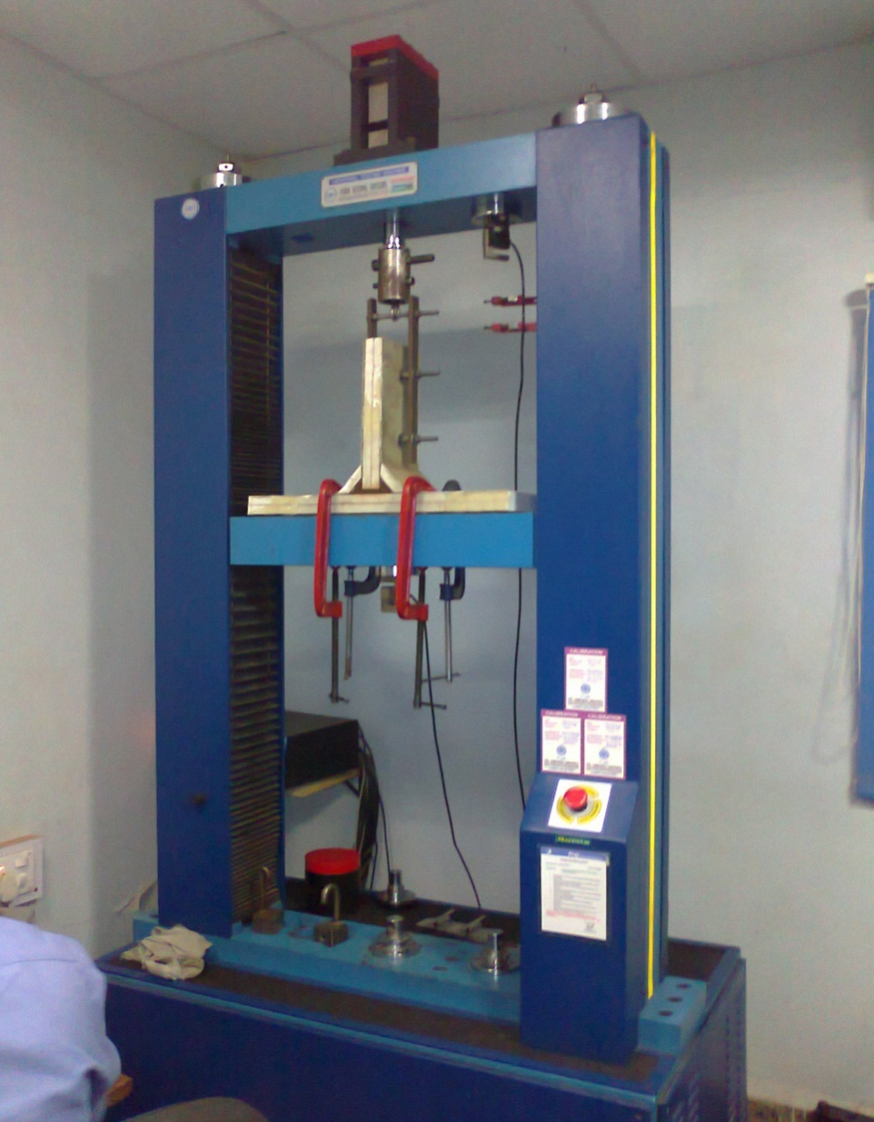

Actual test rig for tensile testing of T-joint.

**8.2.2 Instrumentation and test procedure**

The load is recorded by certified 100KN load cell. The displacement is both recorded as the movement of piston (cross-head) on the tensile machine, and by calibrated linear variable differential transformer device. The tests are also recorded on video and still-photos with the camera in fixed position during the test, showing side view of the T-joint. A voltmeter within the picture frame shows the load cell voltage, for identifying the load level at each individual picture. The tensile test carried out on a 250KN hydraulic testing machine (KIC-2-XXXX-C), at a constant cross-head speed of 5mm/min.

We filled necessary information in computer attached to hydraulic testing machine. This machine operated and controlled by software and result is displayed on the computer screen. We kept initially preload zero and displacement also brought to zero.

**8.2.3 TEST RESULTS**

**Load and displacement**

Plot of load versus cross-head displacement are shown for one of the three specimens in fig 8.4. The initial value of the load is 0.4KN due to pre-stressing and the weight of the square steel tubes and threaded steel rods. The load displacement curve at the center (for x = 0) is almost linear up to load of 19.6 KN (displacement 4.85 mm). Thereafter, the curve becomes slightly non-linear until a load of 29.8 KN (displacement 7.96 mm). From there on, the test sample undergoes heavy deformation for only a slightly increase in load until final failure at a load and displacement of 49.5KN and 11.32mm, respectively.

* 1. **Failure load**

**8.3.1 TRIAL NO 1.**

For first trial the limiting load has kept 3 kN, but it was free for further loading. Load has gradually increased on T-joint with speed of 5 mm/min. Load Vs Displacement curve displayed on computer screen shows progress of gradual loading. At 19.6 KN load, the upper bolt has failed i.e. fixture has failed in trial no.1 but T-joint is not damaged. That means it might take more load.

* + 1. **TRIAL NO. 2:**

The failed bolt in trial no.1 is replaced by high tension bolt of class 8.8. we used special bolt for heavy duty application. The size of bolt is same as that of previous one i.e. M10 X 150. Again same conditions were applied as in case of trial no.1 and results were recorded. At 29.8KN load, the high-tension bolt is failed i.e. failure has occurred again in fixture but there were no harm to T-joint.

* + 1. **TRIAL NO. 3:**

For trial no. 3 we replaced whole fixture by new one. New fixture contained MS plates with thickness more than previous one. We increased Drilled size from 12mm to 16mm. Distance between plates as well as upper surface of vertical plate to jaw is reduced. High tension bolts of size M15 X 150 used in fixing plates as well as to clamp with upper jaw. In this case, T-joint has failed at 49.5KN.

Table 5: - Failure load of static tensile tested T-joint

|  |  |  |  |  |
| --- | --- | --- | --- | --- |
| Value | Unit | Sample-30deg | Sample-45deg | Sample-60deg |
| Failure load | KN | 19.6 | 29.8 | 49.5 |
| Deformation | mm | 4.85 | 7.96 | 11.32 |
| Tensile Stress | N/mm2 | 62.54 | 91.37 | 125.30 |

We have taken 3-test of T-joint on hydraulic testing machine. We are getting different result for each joint as shown in table.



**Chapter 9**

**ANALYSIS of T-joint**

The process methodology adopted in the static analysis of T-joint is described as follows. The T-joint is modeled in design software CATIA V5 which is compatible with the simulation software ANSYS 12.

The CAD model is imported into the simulation software. The first step is preparing a proper process plan for the analysis of the T-joint. This process plan involves building the CAD model, determining the boundary conditions, study the material properties and loading pattern. The material properties and orientation used for each part in various computations are given in table together with description of each part. The elastic constants EX, EY, Gxy and Vxy in the local coordinate system are given together with tensile strength X and Y in the local X-direction and Y-direction respectively. The material are assumed to be linear elastic and orthotropic.

The element (PLANE82) used in the model is a plane 8 node orthotropic element with a 2 x 2 Gauss integration scheme. We used automatic mesh. The automatic mesh initially consists of approximately 10000 elements. The element side length varies from 1mm in the upper skin of panel A and the filler, to 3 mm in the core of panel A and B.

**Table 6:- Material properties for each part in various configurations.**

|  |  |  |  |  |  |  |  |
| --- | --- | --- | --- | --- | --- | --- | --- |
| Part  No. | Part description | Material description | EX  (MPa) | EY  (MPa) | Gxy  (MPa) | S  (MPa) | Vxy |
| 1 | A skin bottom | Glass fiber | 26,100 | 11,500 | 4,400 | 31.4 | 0.14 |
| 2 | A skin top | Glass fiber | 26,100 | 11,500 | 4,400 | 31.4 | 0.14 |
| 3 | B skin | Glass fiber | 26,100 | 11,500 | 4,400 | 31.4 | 0.14 |
| 4 | A Core | PVC Foam | 104 | 104 | 40 | 1.4 | 0.3 |
| 5 | B core | PVC Foam | 104 | 104 | 40 | 1.4 | 0.3 |
| 6 | Filler | Epoxy Resin 520 | 500 | 500 | 170 | 8.7 | 0.47 |

By the finite element analysis, it is possible to understand the failure mechanisms associated with the complex structure of the T-joint by indentifying the critical points and improving them. Fig.9.1 shows the distribution of the stresses σy (in the direction of the Y-axis) for a displacement 8mm. The maximum value is located at the corner where there is a stress concentration.

In ANSYS Von Mises stresses are calculate which given by equation

The effects of changes in the T-Joint geometry (overlaminate angle and hull thickness) were studied by comparing the strain distribution in critical regions of the joint. We are reported their observations of the failure mode for the T-joint under statictensile load. We found that the crack started either from the top corner of the interfacebetween the bulkhead and the over laminate or at the bottom corner of the interfacebetween the hull and the overlaminate, as shown in Figure 9.6. The exact startingposition could not be determined, as even the high speed video camera used to observethe failure has too slow to capture the crack initiation.

The T-Joint loaded as described previously and clamped at the reaction points. The maximum strain in the overlaminate would be expected to occur in the sloping region adjacent to the filler which is subjected to bending and axial loads, both of which are functions of the overlaminate angle and hull thickness. Three regions in the overlaminate were selected for comparison of the strain distribution. These were the top, mid and bottom sections as described in Figure 9.6. The top and bottom corner sections correspond to the regions where failure initiation would be expected, while the mid-section corresponds with the region where the maximum overlaminate strain would be expected.

**MESHING OF COMPOSITE STRUCTURE:**

**Element Size: 5mm**

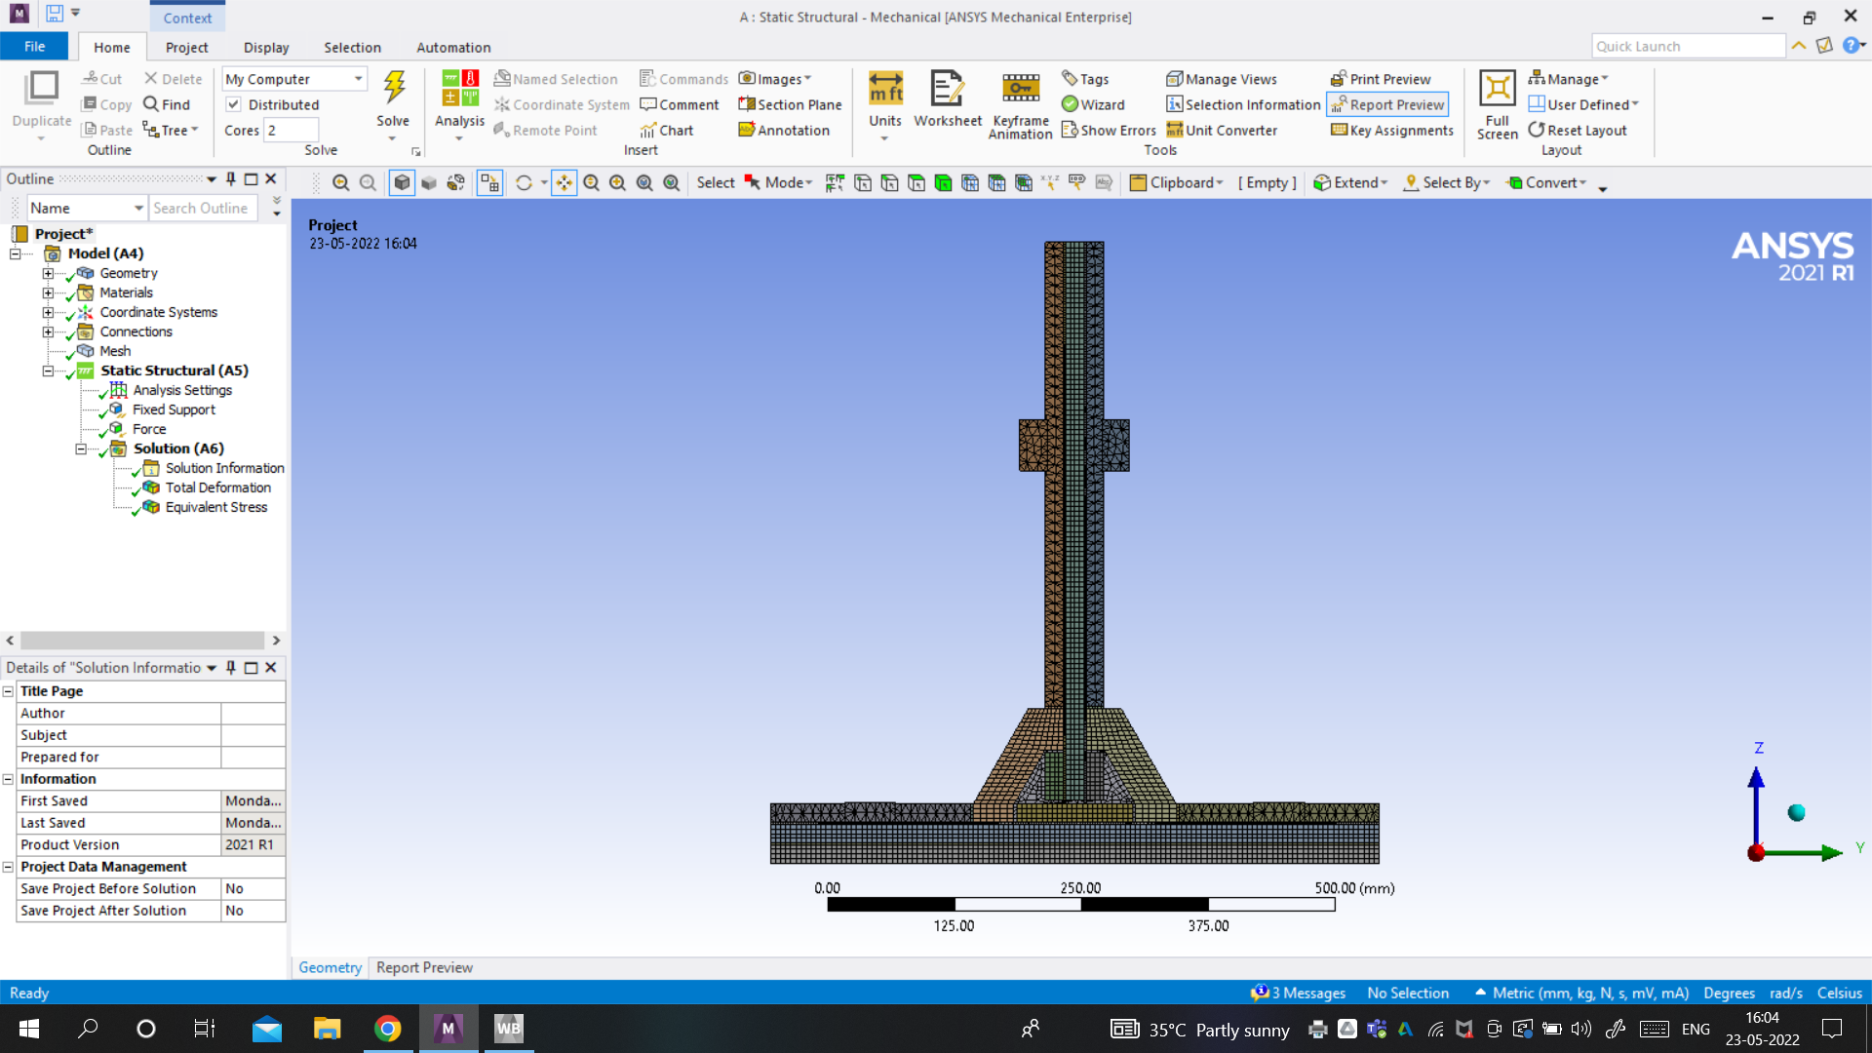

**CONSTRAINTS AND FORCE APPLICATION OF T-JOINT:**

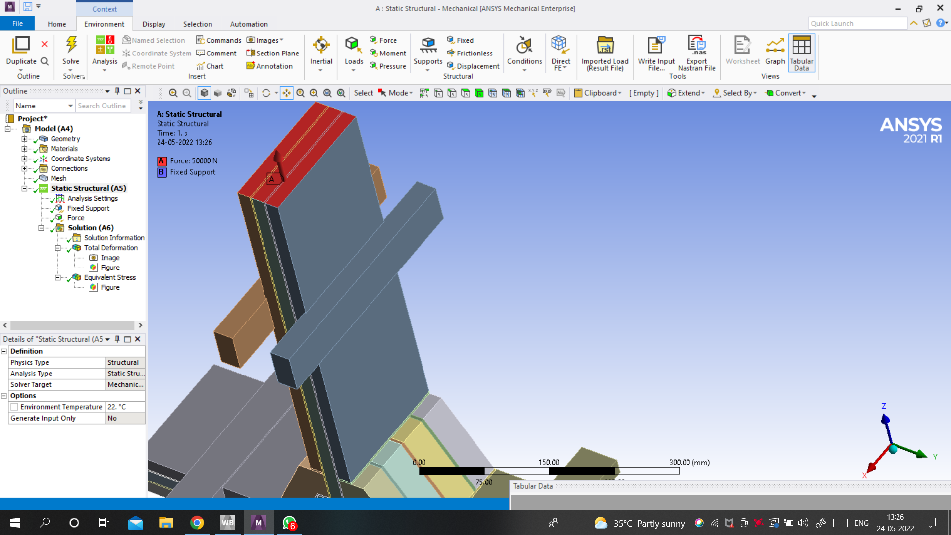

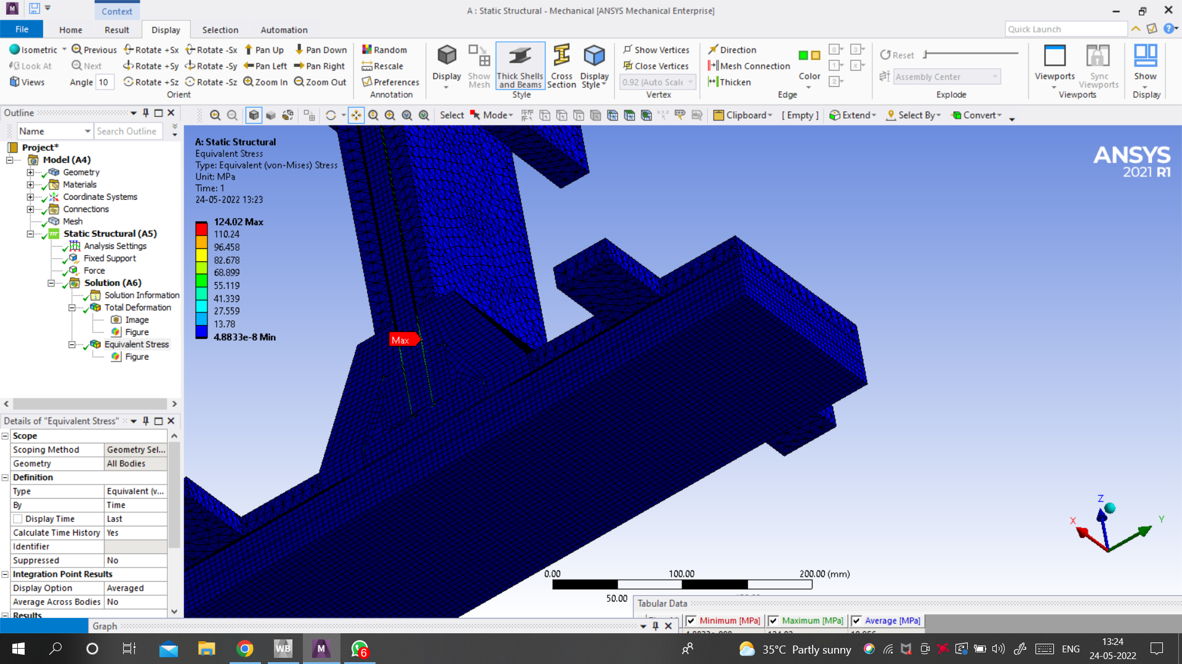

**LOAD APPLICATION:**

|  |  |  |  |
| --- | --- | --- | --- |
| Sr. No. | LOAD APPLIED  (KN) | TOTAL DEFORMATION (mm) | STRESS (MPa) |
| 1 | 20 | 4.3754 | 49.607 |
| 2 | 30 | 6.5631 | 74.411 |
| 3 | 50 | 10.939 | 124.02 |

**Analysis of T-Joint at 20KN load Stress Generation:**

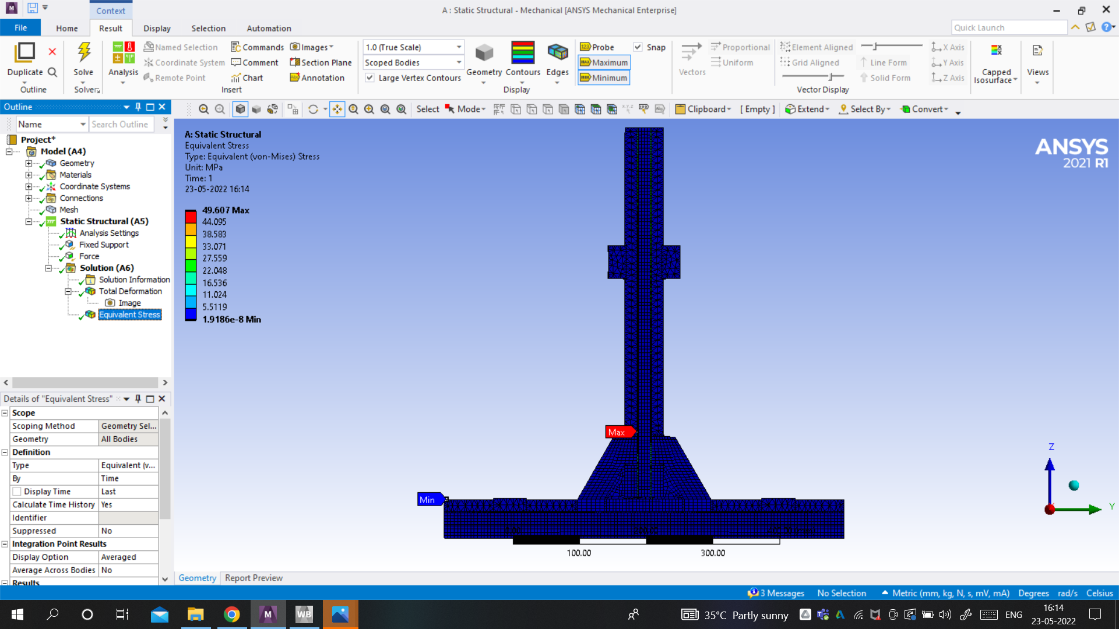

**Deformation Of T-Joint at 20KN load:**

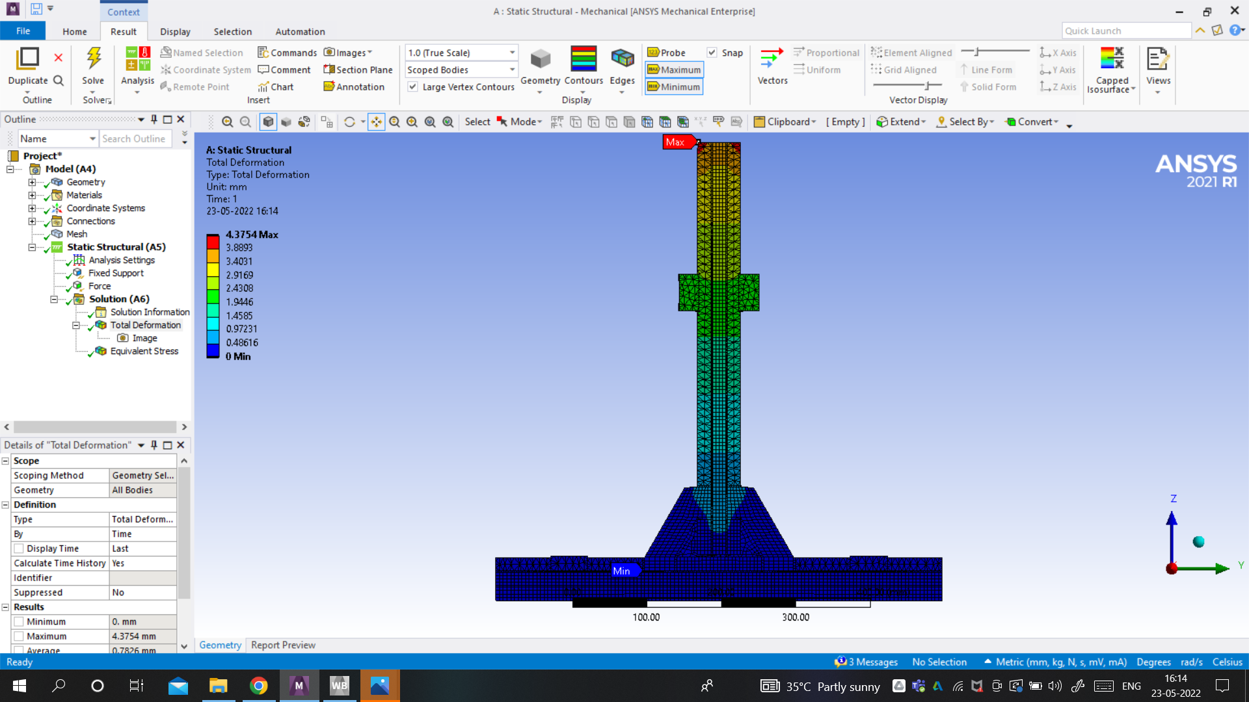

**Analysis of T-Joint at 50KN load:**

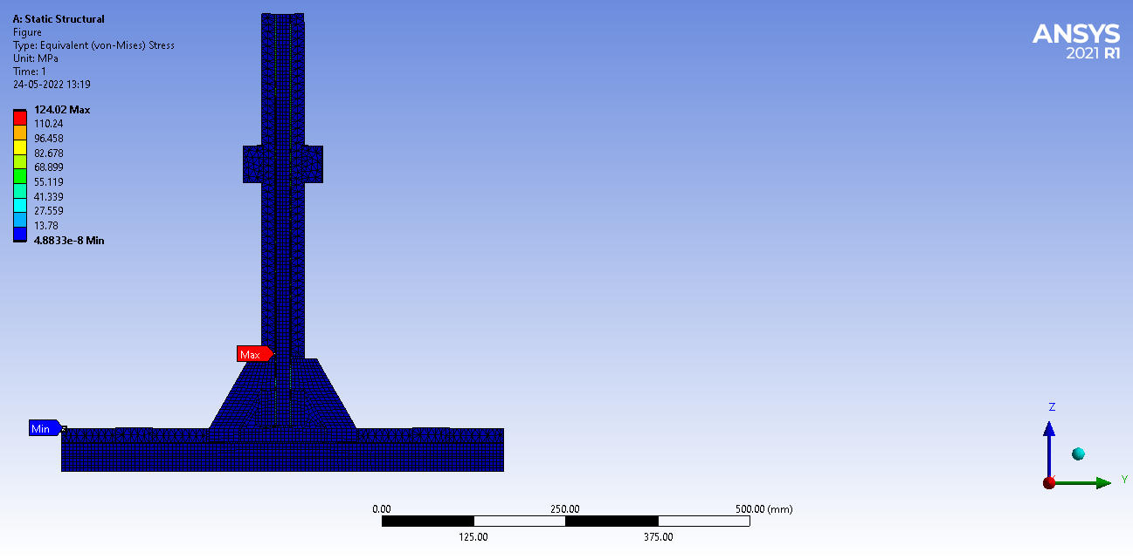

**Deformation Of T-Joint at 50KN:**

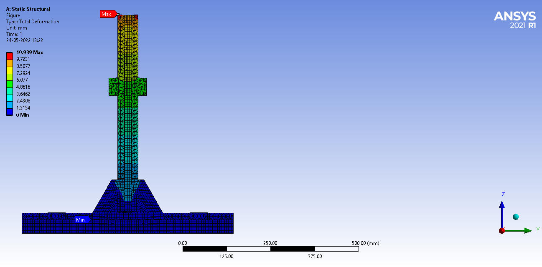

**Chapter 10**

**RESULTS AND DISCUSSION**

The crack initiated from the interface between the over laminate and bottom skin through core A at about 19.8 KN after 8.4 mm displacement. The load versus displacement curve is shown in fig

**Table 7:-Comparison of Results**

|  |  |  |  |
| --- | --- | --- | --- |
| SR. NO. | LOAD (in KN) | ANSYS RESULT  (in mm) | EXPERIMENTAL RESULT (in mm) |
| 1 | 19.6 | 4.32 | 4.85 |
| 2 | 29.8 | 7.25 | 7.96 |
| 3 | 49.5 | 10.93 | 11.32 |

The load increases linearly until a load and a displacement respectively of about 1982N and 0.7mm are reached.

1. The load increases but the slope changes because the base starts to deform. a load and displacement respectively of about 19800N and are 8.4mm are reached. In this case bending of the base element is evident.
2. The load increases but with the lower slope. Moreover, the load shows instability due to shear cracks propagation of the core. Initially micro cracks occur at the bottom skin/core interface of the plating element. Then these cracks propagate in the core showing the typical trend at 600, mainly in presence of the notches of the PVC blocks, starting by the more external one shown in fig 9.6.
3. The load drops drastically due to the simulation failure of the base of the T-joint. The cracks reach the top skin or core interface of the plating element, the sandwich collapse and as a consequence, a crack propagates between the plating top skin and the mat of the over laminate on one side of the T-joint.as shown in fig 9.6.
4. Finally, the load drops drastically due to full failure of the joint. The failure mechanism of this undamaged T-Joint verifies the experiment done by that the failure has always along the over laminate bond line. However, the initial location where the crack begins to grow may be either at the hull- over laminate interface or the bulkhead-over laminate interface. No matter where the crack initiates, the crack will grow along the filler region to cause fracture along the over laminate bond line. We are suggested that the initial crack growth is due to the manufacturing imperfections, such as poor bonding.

According to Finite Element Analysis result, maximum stress has developed on over laminate and bottom skin. Hence it was obviously failed at high stress region i.e. from over laminate.

**Chapter 11**

**CONCLUSIONS**

* The lightweight T-joint is designed for sandwich panels with two sheets of 18 mm thick PVC foam core and 3 mm thick fiberglass skin laminates. The panels are joined by use of filler and two supporting core pieces of PVC foam.
* ANSYS is used for Finite Element study of T-joint with static loading condition.
* We have compared similar joint configurations on the basis of relative stresses in the different parts of the joint. We compared on the basis of Von Mises stress distribution.
* It is found that both hull thickness and over laminate angle affected the critical strains in both the over laminate hull, indicating that in the design of such joints, these effects must be considered.
* The selected sandwich T-joint has been tested in static tension in special designed fixture .
* The T-joint fails in shear in the core of the base panel at a load of 19.8 KN.
* The release of energy from the shear failure of the base panel causes the T-joint itself to fail as well.
* The failure load of new T-joint is nearly 20% higher than that of the reference Base Design T- joint.
* The failure mode is initiated from overlaminate to foam core A by shear failure.
* The load Vs deflection curve is almost linear until a load of 19.8kN.

**Chapter 12**

**FUTURE SCOPE**

1. We can use the different triangular angle in-between hull and bulkhead of t-joint because we are getting more triangular area and improve the strength of t-joint.

2. It is observed that the documented resistance to internal blast is adversely affected by the presence of manufacturing defects. Therefore it is recommended that improved systems be developed to ensure proper implementation of new manufacturing procedures at naval shipyards

3. It is recommended to carry out new internal blast trials to establish the real potential offered by the new improved design. This is because the documented internal blast resistance was adversely affected by manufacturing defects.

4. Good fire behavior has been demonstrated with well-protected composite structures and panels. However, current state of the art does not allow determination of a rational measure of the survivability of a structure to fire, whether steel or composite, and hence does not allow a rational comparison between them. Therefore, increased confidence in the use of composites could be achieved by developing fire safety engineering methods for the design of military ships that take into account the fire properties of all materials present in the fire area such that a rational measure of vulnerability can be computed

**REFERENCES:**

1. D.W. Zhou and L.A. Louca “Numerical simulation of sandwich T-joints under dynamic loading” Composites Part B 39 (2008) 973–98520.
2. G. Di Bella, C.Borsellino “Experimental and numerical study of composite T-joints for marine application” international journal of adhesion & adhesives 30(2010) 347-358.
3. Jeom Kee Paik, Anil K.Thayamballi, Gyu Sung Kim “The strength characteristics of aluminum honeycomb sandwich panels” Thin-walled structures 35 (1999) 205-231
4. Elena Bozhevolnayaa and Ole T.Thomsen “Local effects across core junctions in sandwich panels” Composites: Part B 34 (2003) 509–517.
5. S.M.R. Khalili and A.Ghaznavi “Numerical analysis of adhesively bonded T-joints with structural sandwiches and study of design parameters” International Journal of Adhesion & Adhesives 31 (2011) 347–356.
6. Ferry Dharmawan and Rodney S “Geometry and damage effects in a composite marine T-joint” Australia Composite Structures 66 (2004) 181–187.
7. S.A. Hashim “Adhesive bonding of thick steel adherents for marine structures” Marine Structures {12 (1999) 405}423.
8. Dana M. Elzey “A shape memory-based multifunctional structural actuator panel” International Journal of Solids and Structures 42 (2005) 1943–1955.
9. Jean-Paul Kabche “Experimental characterization of hybrid composite-to-metal bolted joints under flexural loading”. Composites: Part B 38 (2007) 66–78.
10. Matthew Kampner “On using corrugated skins to carry shear in sandwich beams”. Composite Structures 85 (2008) 139–148 PA 18015.
11. .S.W.Boyd “Optimization of steel–composite connections for structural marine applications”. Composites: Part B 39 (2008) 891–906.
12. A.P.Mouritz “Review of advanced composite structure for naval ships and submarines” Composite structure 53 (2001) 21.
13. Aage Lystrup “Design and test of lightweight sandwich T-joint for Naval ships”.Riso national laboratory, DK-4000 Roskilde, Denmark November 2008